**Growing Up**

Dogs grow up fast. I heard that one dog year is the same as seven human years. If a dog lives to be 17 it is like he is 120 in human years. Roger, my dog, was born on March 7th, and every year we give him a special birthday treat to mark that date. But if our year is like seven years to him, maybe we should be giving him special treats more often - first on

March 7th, and then again on April 28th, and then again on June 19th and so on. Imagine having seven birthdays every year! Today I was thinking – if he is growing seven times faster, then maybe one day feels to him like a full week feels to us? Imagine if the sun only set once a week – seven days of sunlight in a row. No wonder he sleeps so much during the day! But all this thinking makes me curious – how old is he really? Is age about the speed we grow up or about the how many years we have been alive?

“Sarah, what are you thinking about?” Ari is sitting with me on the step. “I’ve been thinking about growing up.” I tell him. “It’s about time!” he replies. I laugh. “No not like that - I‘ve been thinking about what growing up feels like and its connection to time.” Ari looks interested. “Sometimes I wonder why some people grow up more slowly, and whether growing up is something we do or whether it just happens to us,” he said. “You mean like Dvir?” I ask him. Dvir is in our class but he doesn’t do the same work as the rest of us. We take turns to help him. “Yes, I wonder what growing up feels like for him.” “Good question” I say, “we should ask him.”

Tal comes and joins us on the step. “Why do we say “growing up” anyway? “, she asks. “Maybe some things *grow down* – like mountains, or pebbles in a stream, or even problems. The older they are the smaller they get “. “You mean they start out big and rough and end up smaller and more refined.” Ari says, finishing off her thought. Meanwhile, I’m thinking to myself that maybe it isn’t so clear with problems – sometimes they grow bigger over time, not smaller.

“Trees are in between – they grow up and grow down at the same time”, Tal continues, “I wonder if the roots start growing down every spring at the same time new shoots are growing upwards?” “Imagine celebrating Tu’Bishvat each year not as the time trees send out new shoots and blossom, but as the time they send out new *roots*?” I add. “We’d all be told to come to school dressed in brown clothes with tree roots in our hair.” Ari would really like that!

Ari and Tal go inside but I stay sitting on the step. I’m still thinking.

I’m thinking that growing up is also like walking backwards. Walking backwards on the beach you can see where you’ve come from by looking at your footprints, but you don’t know exactly where your feet will be next. That is how I feel in life – all the things that have happened to me up until now and all my memories tell me who I am *now* - but I am not exactly sure who I will be tomorrow. An almond tree will grow up to be an almond tree, but I could grow up to be anything.

**Leading Idea: Growing Up and the passage of time**

TuBishvat marks the ‘Birthday of trees’ – but what is it marking? Is it marking the tree’s age or the tree’s growth? In the case of trees, a tree is considered one year old on TuBishvat, even if it is planted a week before TuBishvat. This is important in Jewish law and tradition for determining when the fruit of a tree can first be eaten (fruit that ripens in its fourth year – that is, after its third Tu’Bishvat), and laws of shmitah (sabbatical year when the fruit is not harvested). Other meaning is derived from the time of year in which TuBishvat occurs – and this links it to the concept of growth. TuBishvat actually falls at the midpoint of winter – as spring approaches and the sap in trees begins to flow and trees begin to bud and flower. TuBishvat thus comes to mark a change from being in a state of latency to one of reneed growth.

Each year we get a year older – but how is this connected to *growing up*? When we talk about ‘growing up’, there are several ideas we might have in mind:

* Growing up as getting older – the passage of time. Last year I was 8 and now I am 9 years old.
* Growing up as physical development – growing physiologically from immature to mature. In children we generally also associate this with growing bigger. In older people we
* Growing up as cognitive maturity – growing up as becoming wiser, more nuanced in our understanding of the world. Telling someone to ‘grow up’ in this sense is to tell them to act with more maturity.

Finally, does everything get older over time? Are there some things that don’t age or grow even as time passes?

The following discussion plans and exercises lead us to think more deeply about the connection between time and growth and different forms of growth.

**Growing Up and Growing Old**

* Do you celebrate your birthday? If so, what exactly are you celebrating?
* If we didn’t have time (days, months, years), would we still get older? Would we grow up?
* As we grow older, do our memories grow older?
* As we grow older, do our thoughts grow older?
* If we had a magic lotion that stopped us aging, would we still grow older each year?
* Is it possible that some things become smaller as they grow older? (can you give an example?)
* Could you grow older without growing up?
* What is the difference between growing up and growing older?

**Which of these things grow?**

|  |  |  |  |  |  |  |
| --- | --- | --- | --- | --- | --- | --- |
| **Which of these things Grow?** | Grow bigger | Grow older | Grow up | Don’t Grow | Something else | If you said they grow, how? If you said they don’t grow, why not? |
| Seeds |  |  |  |  |  |  |
| Apples, |  |  |  |  |  |  |
| Dried flowers |  |  |  |  |  |  |
| Your legs |  |  |  |  |  |  |
| Characters in a story |  |  |  |  |  |  |
| Dolls |  |  |  |  |  |  |
| Knowledge |  |  |  |  |  |  |
| Eggs in a nest |  |  |  |  |  |  |
| Balloons |  |  |  |  |  |  |
| God |  |  |  |  |  |  |
| The wind |  |  |  |  |  |  |
| Your temper |  |  |  |  |  |  |
| Problems |  |  |  |  |  |  |
| Your mind |  |  |  |  |  |  |
| Crystals |  |  |  |  |  |  |
| Houses |  |  |  |  |  |  |

**Growth and identity**

* Could you grow if you didn’t have any food?
* Could you grow if you didn’t have any ideas?
* Could you grow if you didn’t have the ability to change?
* Are you the same person today as you were when you were 2 years old?
* Are there some things about us that don’t change as we grow older?
* Are there some things about us that don’t change as we grow up?
* Can we know who we will become?

**Activity:**

1. Walk around your neighborhood block.
   1. Point our all the different types of things you can see that grow bigger as they grow older
   2. Point out all the different types of things that you see that grow up as they grow older
   3. Point out all the kinds of trees you see that bear fruit that we can eat.

Pick one interesting example of each. Tell us about it.

*(If you are able to take photographs of these things, then pick one to share).*

**Leading Idea: Growth as the realization of Potential.**

Another way of thinking about growth is as self-actualization – the realization of inner potential. This idea is also linked to Tu Bishvat. Situated at the midpoint of winter, Tu Bishvat is seen to symbolically mark the transition in trees from a period of dormancy to one of growth (and the coming of spring) in which they come to ‘realize their potential’ by sending out new growth, flowers and producing the next year’s fruits. This concept of growth as the realization of potential has led Tu Bishvat to be symbolically linked to such diverse endeavors as education (the laying of corner tones of universities), the building of Israel as nation and as a time to attend to our spiritual growth as human beings.

The following secondary sources explore this dimension of the meaning of growth and of Tu Bishvat.

The human being is compared to a tree. We must recognize the wonderful potential within every person and every event, and we must commit ourselves to bringing out that potential.

A famous philosopher called John Dewey saw education as *a way of growing*. What do you think this might mean?

**The cornerstone** of a building is a stone put down to mark the starting place in the construction of a monumental building. It is often carved with the date and laid down with a ceremony.

The cornerstone-laying ceremony of these institutions was held on Tu BiShvat

* The [Hebrew University of Jerusalem](https://en.wikipedia.org/wiki/Hebrew_University_of_Jerusalem), in 1918;
* The [Technion](https://en.wikipedia.org/wiki/Technion) (a university specializing in scientific research) in Haifa in1925;

Tu BiShevat was also the date of the first meeting of the **Israeli Knesset** in February 1949.

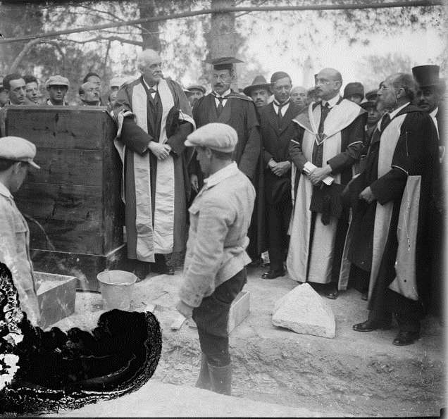Arthur James Balfour about to lay the Hebrew University Cornerstone in 1918.

He also spoke at the opening of the university on April 1st, 1928

https://www.youtube.com/watch?v=UJGI-IaPYik

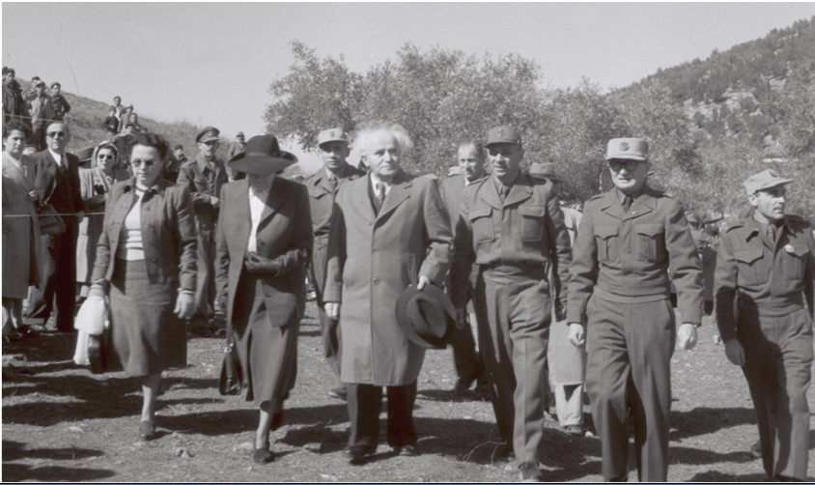

On February 14th 1949 (the 15th of Shevat), which was the [New Year of the Trees](https://www.knesset.gov.il/lexicon/eng/tubishvat_eng.htm), the first meeting took place to try to write a constitution for Israel. Most of the people came to Jerusalem from the coastal area, stopping on their way for a tree-planting ceremony. The ritual of planting trees in Jerusalem and its surroundings have since become aa regular part of the Knesset's birthday celebrations.

https://www.knesset.gov.il/birthday/eng/EarlyYears_eng.htm

Once while Hone HaMa’agal (the circle-maker) was walking down the road, he saw a man planting a carob tree. Honi asked, “How many years will it take for this tree to bear fruit” The man answered that it would take 70 years. Honi said, “Are you so healthy that you expect to live that long to enjoy its fruit?” The man answered, “I found a fruitful world, because those who lived before me planted trees for me. In the same way, I shall do this for my children.” ( *Babylonian Talmud, Ta’anit 23a*)

Shimon bar Yochai: “if you are holding a sapling in your hand and someone says that the Messiah has drawn near, first plant the sapling, and then go and greet the Messiah.” *Avot d’Rebbe Natan* 31b

Drawing/Writing

**Leading Idea: Tree as metaphor**

Metaphors capture the qualities of one thing through the imagery of another (“He gave a lion’s roar”). It is more than a comparison (“His scream was *like* a lions roar”) becomes it suggests that the object (the lion) – or some quality of the object - is part of what he is (and expressed in the sound he made).

The tree has been an important metaphor in Judaism for both describing the Torah and describing a person.

The following quotes explore the tree as metaphor. The exercises are designed to help students understand the concept of a metaphor.

**Exercise: Capturing meaning through metaphor**

*What qualities do you think are being described in the following sentences?*

1. He had a mountain of troubles
2. Her words were pearls of wisdom
3. He felt a wave of emotions
4. Her bark was worse than her bite
5. He had a sharp mind

**Exercise: The difference a metaphor makes.**

*Which image do you think is better? Why?*

1. To see a person as a tree or to see them as a rock?
2. To think of your life as a journey or to think of it as a story?
3. To think of the test you have tomorrow as a hurdle or to think of it as a game?

**“The Torah is a tree of life”**

***Mishlei (Proverbs) 3:18***