|  |  |
| --- | --- |
| **א**  וּמֹשֶׁה, הָיָה רֹעֶה אֶת-צֹאן יִתְרוֹ חֹתְנוֹ--כֹּהֵן מִדְיָן; וַיִּנְהַג אֶת-הַצֹּאן אַחַר הַמִּדְבָּר, וַיָּבֹא אֶל-הַר הָאֱלֹהִים חֹרֵבָה.  **Shemot 3 שמות** | 1 Now Moshe was looking after the flock of Yitro his father-in-law, priest of Midyan; and he led the flock behind the wilderness [to the West, to the end of the wilderness], and came to the mountain of God, Horev. |
| **ב**  וַיֵּרָא מַלְאַךְ יְהוָה אֵלָיו, בְּלַבַּת-אֵשׁ--מִתּוֹךְ הַסְּנֶה; וַיַּרְא, וְהִנֵּה הַסְּנֶה בֹּעֵר בָּאֵשׁ, וְהַסְּנֶה, אֵינֶנּוּ אֻכָּל. | 2 And God’s messenger was seen by him in the flame of a fire –from inside a bush. He saw: here, the bush is burning with fire, and the bush is not consumed! |
| **ג**  וַיֹּאמֶר מֹשֶׁה--אָסֻרָה-נָּא וְאֶרְאֶה, אֶת-הַמַּרְאֶה הַגָּדֹל הַזֶּה:  מַדּוּעַ, לֹא-יִבְעַר הַסְּנֶה. | 3 And Moshe said: Now let me turn aside, and see this great sight: why, the bush does not burn up! |
| **ד**  וַיַּרְא יְהוָה, כִּי סָר לִרְאוֹת; וַיִּקְרָא אֵלָיו אֱלֹהִים מִתּוֹךְ הַסְּנֶה, וַיֹּאמֶר מֹשֶׁה מֹשֶׁה--וַיֹּאמֶר הִנֵּנִי. | 4 And when God saw, that he turned aside to see, God called to him out of the bush, and said: Moshe!, Moshe! And he said: 'Here am I.' |
| **ה**  וַיֹּאמֶר, אַל-תִּקְרַב הֲלֹם; שַׁל-נְעָלֶיךָ, מֵעַל רַגְלֶיךָ--כִּי הַמָּקוֹם אֲשֶׁר אַתָּה עוֹמֵד עָלָיו, אַדְמַת-קֹדֶשׁ הוּא. | 5 And He said: 'Do not come closer; take off your sandal from off your foot, for the place on which you stand - it is holy ground.' |
| **ו**  וַיֹּאמֶר, אָנֹכִי אֱלֹהֵי אָבִיךָ, אֱלֹהֵי אַבְרָהָם אֱלֹהֵי יִצְחָק, וֵאלֹהֵי יַעֲקֹב; וַיַּסְתֵּר מֹשֶׁה, פָּנָיו, כִּי יָרֵא, מֵהַבִּיט אֶל-הָאֱלֹהִים. | 6 And He said: I am the God of your father, the God of Avraham, the God of Yitzak, and the God of Yakov. And Moshe hid his face; for he was in awe, to look upon God. |
| **ז**  וַיֹּאמֶר יְהוָה, רָאֹה רָאִיתִי אֶת-עֳנִי עַמִּי אֲשֶׁר בְּמִצְרָיִם; וְאֶת-צַעֲקָתָם שָׁמַעְתִּי מִפְּנֵי נֹגְשָׂיו, כִּי יָדַעְתִּי אֶת-מַכְאֹבָיו. | 7 And God said: I have seen - seen the affliction of My people that are in Egypt, and their cry I have heard, in the face of their slave-drivers; indeed, I have known their suffering1 |
| **ח**  וָאֵרֵד לְהַצִּילוֹ מִיַּד מִצְרַיִם, וּלְהַעֲלֹתוֹ מִן-הָאָרֶץ הַהִוא, אֶל-אֶרֶץ טוֹבָה וּרְחָבָה, אֶל-אֶרֶץ זָבַת חָלָב וּדְבָשׁ--אֶל-מְקוֹם הַכְּנַעֲנִי, וְהַחִתִּי, וְהָאֱמֹרִי וְהַפְּרִזִּי, וְהַחִוִּי וְהַיְבוּסִי. | 8 So I have come down to rescue them from the hand of Egypt, to bring them up out of that land, goodly and spacious [large], to a land flowing with milk and honey; to the place of the Canaanite, and the Hittite, and the Amorite, and the Perizzite, and the Hivvite, and the Yevusite. |
| **ט**  וְעַתָּה, הִנֵּה צַעֲקַת בְּנֵי-יִשְׂרָאֵל בָּאָה אֵלָי; וְגַם-רָאִיתִי, אֶת-הַלַּחַץ, אֲשֶׁר מִצְרַיִם, לֹחֲצִים אֹתָם. | **9**And so now, here, the cry of the Children of Israel has come to Me; and I have also seen the oppression with which the Egyptians oppress them. |
| **י**  וְעַתָּה לְכָה, וְאֶשְׁלָחֲךָ אֶל-פַּרְעֹה; וְהוֹצֵא אֶת-עַמִּי בְנֵי-יִשְׂרָאֵל, מִמִּצְרָיִם. | **10** So- now go, for I send you to Paro - bring My people the Children of Israel out of Egypt! |
| **יא**  וַיֹּאמֶר מֹשֶׁה, אֶל-הָאֱלֹהִים, מִי אָנֹכִי, כִּי אֵלֵךְ אֶל-פַּרְעֹה; וְכִי אוֹצִיא אֶת-בְּנֵי יִשְׂרָאֵל, מִמִּצְרָיִם. | **11** And Moshe said to God: 'Who am I, that I should go to Paro, and that I should bring the Children of Israel out of Egypt?' |
| **יב**  וַיֹּאמֶר, כִּי-אֶהְיֶה עִמָּךְ, וְזֶה-לְּךָ הָאוֹת, כִּי אָנֹכִי שְׁלַחְתִּיךָ:  בְּהוֹצִיאֲךָ אֶת-הָעָם, מִמִּצְרַיִם, תַּעַבְדוּן אֶת-הָאֱלֹהִים, עַל הָהָר הַזֶּה.  **יג**. וַיֹּאמֶר משֶׁה אֶל הָאֱלֹהִים הִנֵּה אָנֹכִי בָא אֶל בְּנֵי יִשְׂרָאֵל וְאָמַרְתִּי לָהֶם אֱלֹהֵי אֲבוֹתֵיכֶם שְׁלָחַנִי אֲלֵיכֶם וְאָמְרוּ לִי מַה שְּׁמוֹ מָה אֹמַר אֲלֵהֶם:  **יד**. וַיֹּאמֶר אֱלֹהִים אֶל משֶׁה אֶהְיֶה אֲשֶׁר אֶהְיֶה וַיֹּאמֶר כֹּה תֹאמַר לִבְנֵי יִשְׂרָאֵל אֶהְיֶה שְׁלָחַנִי אֲלֵיכֶם:  **טו.** וַיֹּאמֶר עוֹד אֱלֹהִים אֶל משֶׁה כֹּה תֹאמַר אֶל בְּנֵי יִשְׂרָאֵל יְהֹוָה אֱלֹהֵי אֲבֹתֵיכֶם אֱלֹהֵי אַבְרָהָם אֱלֹהֵי יִצְחָק וֵאלֹהֵי יַעֲקֹב שְׁלָחַנִי אֲלֵיכֶם זֶה שְּׁמִי לְעֹלָם וְזֶה זִכְרִי לְדֹר דֹּר: | **12** And He said: 'Certainly I will be there with you; and this is the sign for you, that I myself have sent you: when you have brought the people out of Egypt, you will [all] serve God upon [by] this mountain.'  **13**:Moshe said to God: Here, I will come to the Children of Israel and I will say to them: The God of your fathers has sent me to you, and they will say to me: What is his name? – what shall I say to them?  **14**: God said to Moshe: [Ehyeh asher ehyeh](http://jbq.jewishbible.org/assets/Uploads/384/384_Ehyeh.pdf) (I will be what I will forever be*), and He said: So shall you say to the Children of Israel: Ehyeh (I will be) has sent me to you.  **15**: And God said further to Moshe: So shall you say to the Children of Israel: Ehyeh (I will be), the God of your fathers -the God of Avraham, the God of Yitzhak, and the God of Yaakov - sends me to you. That is my name for all time; that is my title (from) generation to generation. |

* Also translated as: “I will ever be what I now am” (JPS), or “I will be howsoever I shall be” (Everett Fox) or “I am that I am” (J.H.Hertz). See also: <http://jbq.jewishbible.org/assets/Uploads/384/384_Ehyeh.pdf>

**Leading Idea: What do we think about God?**

This encounter between God and Moshe opens up an opportunity for students to explore their own ideas about God. How do they understand God talk? It is very important to remember that the goal is not to lead everyone to any particular position on God, or even belief in God, but rather, to offer them a wide range of possible ways of thinking about God and to offer them a richer more nuanced language through which they might reflect on their own theological ideas , understandings, challenges, uncertainties and commitments. After the discussion guide there are several quotes from different sources that students could read and discuss.

**Discussion Plan: Our Ideas of God**

*The idea of God can be something we wrestle with for a very long time; for some people for their entire lives. Indicate what you think of the following possibilities (these possibilities reflect many philosophical positions in Western and Jewish thought). For each possibility, consider how it would affect the way we thought about the world and life.*

1. Is it possible that God once existed, but no longer exists?
2. Is it possible that God is nature? (if so, what might this mean?)
3. Is it possible that God is something beyond the world (beyond nature?)
4. Is it possible that God exists within you? What might this mean?
5. Is it possible that God is a physical being?
6. Is it possible that God is an literary character? A character in the Bible rather than a force in the world?
7. Is it possible that God is female?
8. Is it possible that God does not exist?
9. Is it possible that God exists as an ideal (like peace or justice)?
10. Is it possible that God is everything and we are a part of God?
11. Is it possible that God is another name for our conscience?

**Discussion Plan: Believing**

1a. Can you know something without believing it?

1b. Can you believe something without knowing it?

2a. Can you believe something you doubt?

2b. Can you doubt something you believe and continue to believe it?

3a. Can you understand something without believing it?

3b. Can you believe something without understanding it?

4. If you say you believe in fair play, does that mean that you:

1. think there is fair play
2. think there ought to be fair play
3. think that it is reasonable to expect there to be fair play
4. Are making a conscious choice to believe that fair play is a good thing..
5. Something else
   1. If you say you believe that there are ghosts, does that mean you:
6. Think there are ghosts
7. Think there ought to be ghosts
8. Think that it is reasonable to expect there to be such things as ghosts
9. Are making a conscious choice to believe that ghosts are real.
10. Something else
    1. If you say that you believe in God does that mean that you:
    2. Think there is a God
    3. Think that there ought to be a God
    4. Think that it is reasonable to expect there to be a God
    5. Are making a conscious choice to believe that ‘God exists’ is true.
    6. Something else

**Think about your own life:**

* Are their things that you aren't certain about but still believe in?
* How do you think you have arrived at these beliefs?
* Are their people or ideas that you think you will *always* believe in?
* Can we consciously choose to believe something? Can we consciously choose to believe *in* something?

**Leading Idea: Belief and Faith are not the same**

What does it take to believe in God? To have faith in his or her existence? Faith has different meanings – it might mean:

1. *To trust in someone or something* – for instance, in lending you money I have faith that you will do the right thing and pay me back.
2. *To believe without having good reasons to support that belief* - for instance, I can have faith that there will be peace in the world one day.
3. *To commit to something by an act of will - to be loyal.* For instance, I might have faith in you that you will win the race because I am committed to you” - it would be disloyal to say (or think) that you don’t have a chance of winning.

Faith is different than belief because belief is grounded in reasons. If I say that I believe the White Sox will win against the Red Sox, I can be asked on what basis I am making that judgment – what evidence do I have that suggests they will win? However; if I say I have faith that the White Sox will win against them, then I am saying that while I have no reason for believing they are the better team, I am ‘backing them’ anyway and giving them my support.

God talk can rest on belief or faith. Given a central theme of this unit concerns wrestling with God, the distinction between believing in God and having faith in God might come up.

The following two quotes challenge the idea that faith comes out of nowhere. The first quote from Shemot Rabbah suggests that belief ‘on evidence’ (God first rescues Israel, then they believed) is more appropriate than faith. Whereas the quote from Heschel challenges the idea that faith is ungrounded. Heschel suggests that faith is the end result of a process, not a first step - a ‘leap’ taken *ex-nihilo* (*out of nothing*).

**If the students are discussing the idea of God, it might be helpful to look at the following three texts in order to get them to explore their own assumptions vis-à-vis belief and faith.**

**Bereshit 28: 16-21**

Look up Ya’akov’s dream, the awe he feels after it, and the reasoning he then goes through regarding what it would take in order for him to accept the Lord as his God.

**A woman came to the Belzer Rebbe** entreating his help through prayer. He asked whether she had sufficient faith. Said she: “In the Torah it is written that God first rescued Israel and

that [only] then they believed”

*Shemot Rabbah 15:2*

**There is no faith at first sight**. A faith that comes into being like a butterfly is ephemeral. He who is swift to believe is swift to forget. Faith does not come into being out of nothing, inadvertently, unprepared, as an unearned surprise. Faith is preceded by awe, by acts of amazement…

Abraham Joshua Heschel, *God in Search of Man*, p.153

**Faith**

**== Belief**

**Think about your own life:**

* Do you think that there are aspects of Jewish life that are more about what you do – the way you live - than about what you believe?
* Do you think that there are aspects of being Jewish that are more about faith and/ or belief than about what you do or don't do?
* To what extent do you think belief and/or Faith in God is important in order to be 'a good Jew'?
* To what extent do you think that you need to have belief or faith *in Judaism* (in it's value) to be a good Jew?
* Which of the readings and/or discussions in this unit resonated with you the most?
* What questions are now foremost in your mind?

**Discussion: Knowledge and ignorance – four logical possibilities**

In small groups, fill out examples for the four categories.

**Know Don’t know**

|  |  |
| --- | --- |
| **Things I know that I know**  **Know Don’t know** | **Things that I don’t know that I know** |
| **Things that I know that I don’t know** | **Things that I don’t know that I don’t know** |

In what square would you put ‘God exists’ and ‘God does’t exist’?

**Leading Idea: The feeling of Awe**

When Moses experieces the burning bush and God’s voice the text tells us he was ‘awestruck’ (יָרֵא). This word is also often translated as fear. The same term, for instance, is used to describe the Israelites feeling as the Egyptian army came toward them at the Reed sea and when Yaakov wakes from his dream of the ladder. Some have also described this feeling as a sense of our own smallness in the face of something much larger than ourselves (to sense it or be swept up in it). In other contexts ירָא השמיים, - fear of the heavens – is seen as the kind of awe, or fear, in which we are acutely aware of our responsibilities in relation to what it means to live in God’s presence.

In the following discussion plan and exercises we explore these meaning of awe.

**Discussion Plan: The experience of Awe**

1. Are there times you can think of when you have been stuck with awe? Can you describe the situation and feeling?
2. When we say something is ’awesome’, what might we mean?
3. When we say something is awe-inspiring, what might we mean?
4. If you are in awe of someone else – does this mean you are afraid of them?

5. If you find something awesome, does that mean it has to be good?

6. Are there times where you are aware of the world around you as mysterious?

7. If you are in awe of something does that mean you are amazed by it? Explain?

8. Does being in awe – or seeing something as awesome – require you to *look at it* a different way than you usually look at things?

**Exercise: The experience of awe**

|  |  |  |  |  |  |  |
| --- | --- | --- | --- | --- | --- | --- |
| **Each of these experiences are ones which someone might describe as being ‘ירא‘ - ‘awesome’ or as themselves ‘being struck with awe’ – which kinds of ‘ירא‘ might they mean?** | Amazing – Astonishing | The feeling that this is a moment of great significance that carries with it responsibilities | The feeling of being swept up in something much larger than myself | Fear | A moment of realization – of insight when it all made sense to me | A feeling of Reverence,  ( deep respect or awe toward another person, or awe toward God) |
| Watching the man on the High-wire do a somersault |  |  |  |  |  |  |
| Being part of the human wave in the soccer stadium |  |  |  |  |  |  |
| A father on first seeing his new-born child (or you seeing your baby brother/sister for the first time) |  |  |  |  |  |  |
| On Kol Nidre in synagogue, as you enter the spirit of Yom Kippur |  |  |  |  |  |  |
| The feeling that can overcome you when all the pieces of a problem fall into place and you suddenly know what to do. |  |  |  |  |  |  |
| Walking up to the front of the synagogue to say a prayer or give a speech to everyone in the congregation. |  |  |  |  |  |  |
| The feeling you have when your parents do something that shows how much they care about you –leaving you in awe of the kind of parents they are |  |  |  |  |  |  |
| You are at a safari park when an elephant starts coming toward you, looking like it is ready to charge. |  |  |  |  |  |  |
| You are on the top of a mountain and see a beautiful sunrise |  |  |  |  |  |  |

**Intertextual Exploration: ‘ירא‘**

**Look up the following passages:**

**Which kind of ,’awe’ do you think best describes this moment of ‘ירא‘ ?**

Bereshit 18:15;

Bersehit 32:12.

Vayikra 19:3

Shemot 14:31.

* Do you agree with the choice of word the translator has used?
* Look at different Torah translations (Everrett Fox, Plaut, Etz Haim, etc,) - what choices do they make?

**Leading Idea: What is a Miracle?**

Miracles link us to the ‘extra-ordinary’ – but what is extraordinary? For some, miracles point to an act of God, for others miracles are something that inspire awe and wonder. The burning bush that is not consumed/burnt up seems to be ‘a miracle’ - but in what ways might we try to understand it? The ongoing Jewish conversation around “What is a miracle” offers many possibilities. For further Jewish texts on this look at the sourecs on the splitting of the reed sea in the curricula material on Beshalach.

* Something that went against the laws of nature (because fire burns)
* An act of God – but something that happened within the laws of nature
* Not extra-ordinary in itself – but the ‘miracle’ involved the fact that it occurs at ‘just the right moment’ and drew Moses attention nd the real miracle was God, or a messangr of God, being present.
* Miracles as natural phenomena – the ‘miracle’ lies in the way we see things – seeing things with awe, wonder, or radical amazement

The following discussion plans, exercises and texts explore different understanding of ‘miracle’ in everyday use and offer resources for exploring the miracle of the burning bush (which has many elements: the bush itself ‘burning’, the messenger of God in the flames (Shemot 3:2) , God speaking to Moshe, Moshe hearing God, God remembering /acting upon his promise to Avram, etc)

**Discussion Plan: Miracles**

**Discuss what the term ‘miracle’ means in each of these sentences**

1. “It was a miracle he survived the accident”
2. “At Hannukah we talk about the miracle of the oil”
3. “When my baby brother was born and I saw him for the first time I thought ‘this is a miracle’”
4. “The trapeze artist performed miraculous feats of daring”
5. “My biology teacher talks about the miracle of life on earth”
6. “It was a miracle that I got my homework done on time”
7. “The magician pulled a rabbit out of the hat – it was a miracle!’
8. I used to take butterflies for granted, but now we have studied them, I think each one is a tiny miracle!

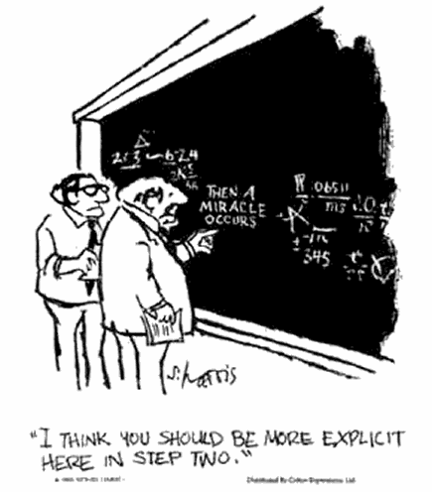

**Discussion Plan: What counts as a miracle?**

1. As I was walking home I was thinking “wouldn’t it be great to have money to buy an ice-cream” - and then I saw a dollar coin in the gutter.
2. In the storm, a bolt of lightning came down and split the tree in half.
3. I fell off my bike speeding down the hill, but came out of it without even a scratch.
4. When the apartment block caught fire, I prayed that everyone would get out of the fire safely and they did.
5. I wake up every morning refreshed and ready to start the day.
6. When the forest fire was out of control, the wind turned and the rain came and put it out.
7. The fortune teller told my sister that she would meet someone and fall in love and she did.
8. God created the world in seven days.
9. Jonah was swallowed by a whale/big fish and survived. (*is this the same as no.8*?)
10. I prayed that something bad would happen to the boy at school who is always teasing me, and then he broke his arm.

*(How does your answer here compare to your answer to no. 5?)*

1. A standard 747 airplane weighs more than 910,000lbs when it is loaded, and

yet it can still get off the ground!

**Exercise: What counts as a miracle?**

For the items listed above (1-12) decide which word best describes it.

Miracle Miraculous Awesome Lucky Ordinary

**Can Human Beings bring about Miracles or only God?**

**China’s Miracle Man**:

*Monday, July 9, 2007*. He survived against all the odds; now Peng Shulin has astounded doctors by learning to walk again. When his body was cut in two by a lorry in 1995, it was little short of a medical miracle that he lived. It took a team of more than 20 doctors to save his life.

Doctors at the China Rehabilitation Research Centre in Beijing found out about Mr Peng’s plight late last year and devised a plan to get him up walking again.

They came up with an ingenious way to allow him to walk on his own, creating a sophisticated egg cup-like casing to hold his body with two bionic legs attached to it.

He has been taking his first steps around the centre with the aid of his specially adapted legs and a resized walking frame. Mr Peng, who has to learn how to walk again, is said to be delighted with the device.

What self-confidence… and optimism…





**The Jewish Miracle**

***In the former Soviet Union we actually have to educate the people from the beginning. Many don't know what Shabbat is, what Chagim [festivals] are, what Aleph-Beth [Hebrew alphabet] is, etc. [but] there is courage.***

There is indeed a lot of courage! When I first came to work as a rabbinical student in Minsk - I grew up in St. Petersburg - I was amazed how many people actually took on their Jewishness and started to act according to their Jewishness. I was amazed at how many people chose not to hide, which is a very good sign! Every day people enter my congregation who choose to rediscover their Jewish identity. A lot of them hid their Jewishness during the Communist years and many are still afraid to accept themselves as Jews. We need to tell them every day: Be courageous! Be honest to yourself! So hopefully - that is my vision - our young people from the former Soviet Union, from Eastern Europe will go and study for the rabbinate and, which is even more important, will return to be rabbis here…. I invite all of you to come to the former Soviet Union to see with you own eyes the Jewish miracle that is happening every day.

*Rabbi Nelly Shulman, born in St. Petersburg, Russia, received her rabbinical ordination at the Leo Baeck College in London in 1999.*

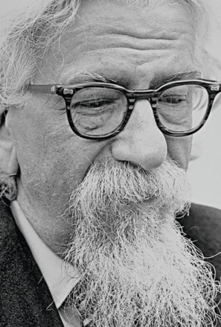**Avraham Joshua Heschel** introduces the term 'the legacy of wonder' or 'radical amazement' referring to how Biblical figures interpreted miracles and their meaning for humans living in contemporary times. He wrote: "What stirred their souls was neither the hidden nor the apparent, but 'the hidden in the apparent'; not the order but the mystery of the order that prevails in the universe." (God in Search of Man, p. 56)

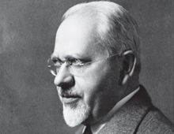

**Mordechai Kaplan** explains the miracles in Jewish literature as reflecting the attempt "of the ancient authors to prove and illustrate God's power and goodness" (Judaism as Civilization, p. 98) Kaplan maintained that these traditions concerning miracles were in conflict with modern thought, and that the belief in miracles that contravene natural law is a "psychological impossibility for most people." (Questions Jews Ask, p. 155-156)

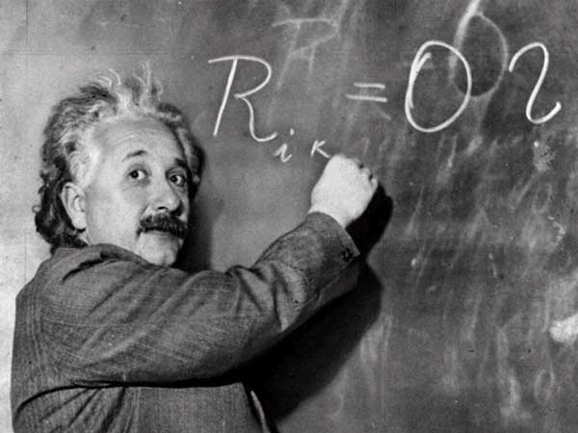

# Albert Einstein

# “There are two ways to live: you can live as if nothing is a miracle; you can live as if everything is a miracle.”

### Evidence & Belief

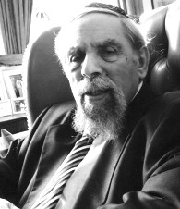The real question for moderns is not *can* miracles happen, but did they and do they happen. As Hume recognized, the question is one of evidence. Many events that were seen in the past as miracles can now be understood as due to the operation of natural laws, even though Hume himself is less than categorical about the absolute necessity of cause *A*always to produce the effect *B*it usually seems to produce.

Undoubtedly, a modern Jewish believer will be far less prone to attribute extraordinary events to a supernatural intervention, but his belief in God's power will not allow him to deny the very possibility of miracles occurring.

A Hasidic saying has it that a Hasid who believes that all the miracles said to have been performed by the Hasidic masters actually happened is a fool, but anyone who believes that they could not have happened is an unbeliever. The same can be said of miracles in general.

*Rabbi Dr. Louis Jacobs (1920-2006) was a Masorti rabbi, the first leader of Masorti Judaism (also known as Conservative Judaism) in the United Kingdom, and a leading writer and thinker on Judaism.*

**Hume on Miracles**

<http://www.fordham.edu/halsall/mod/hume-miracles.asp>

*The Scottish philosopher David Hume (1711-1776) launched an effective critique of miraculous claims. This sceptical rationalism was a major challenge to religious belief throughout the later 18th and 19th centuries.*

**From David Hume. *An Enquiry Concerning Human Understanding***

A miracle is a violation of the laws of nature; and as a firm and unalterable experience has established these laws, the proof against a miracle, from the very nature of the fact, is as entire as any argument from experience can possibly be imagined. Why is it more than probable, that all men must die; that lead cannot, of itself, remain suspended in the air; that fire consumes wood, and is extinguished by water; unless it be, that these events are found agreeable to the laws of nature, and there is required a violation of these laws, or in other words, a miracle to prevent them? Nothing is esteemed a miracle, if it ever happen in the common course of nature. It is no miracle that a man, seemingly in good health, should die on a sudden: because such a kind of death, though more unusual than any other, has yet been frequently observed to happen. But it is a miracle, that a dead man should come to life; because that has never been observed in any age or country. There must, therefore, be a uniform experience against every miraculous event, otherwise the event would not merit that appellation....

**Rabbinic notion of daily miracles**: "Come and consider how many miracles the Holy One blessed be He, performs for man, and he is unaware of it. If a man were to swallow unmasticated bread, it would descend into his bowels and hurt him terribly, but God created a well in the throat of man which enables it to descend safely." (Exodus Rabba 24:1).

This idea is expressed in the daily prayer (modim anachnu lach) "For Thy miracles which are daily, and for Thy wonders and Thy benefits, which are wrought **at all times, evening, morning and night**."

**How do these artworks portray the phenomenon of the burning bush?**





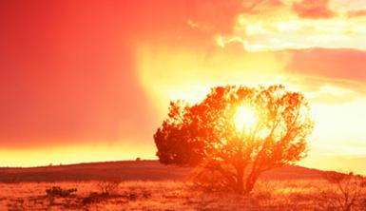

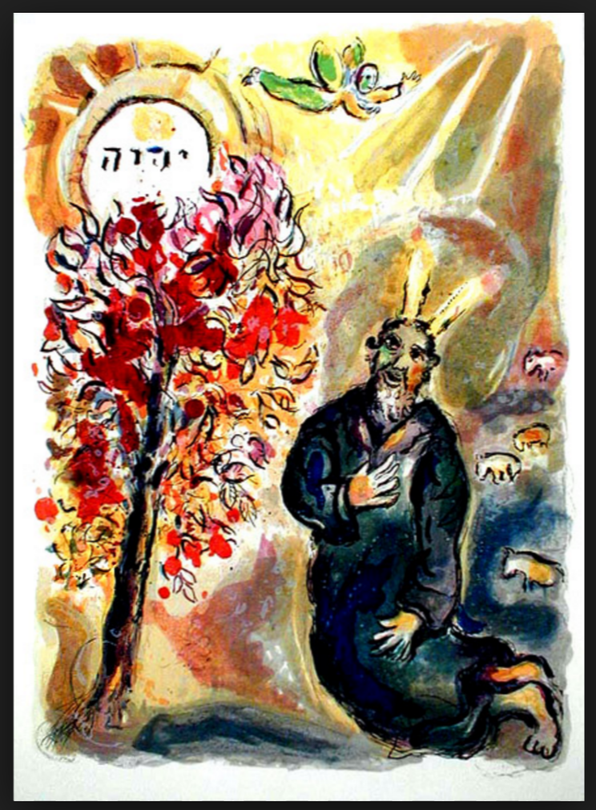Chagall: Moses nd the Burning Bush (1966)

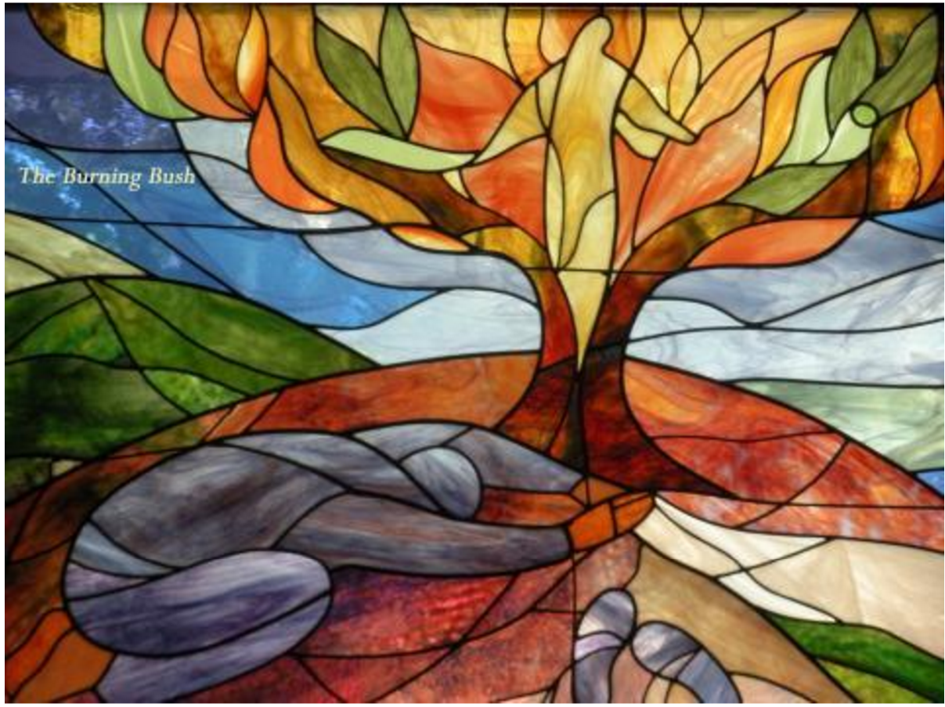

http://www.customandcraft.org/blog/artwork-your-haggadah

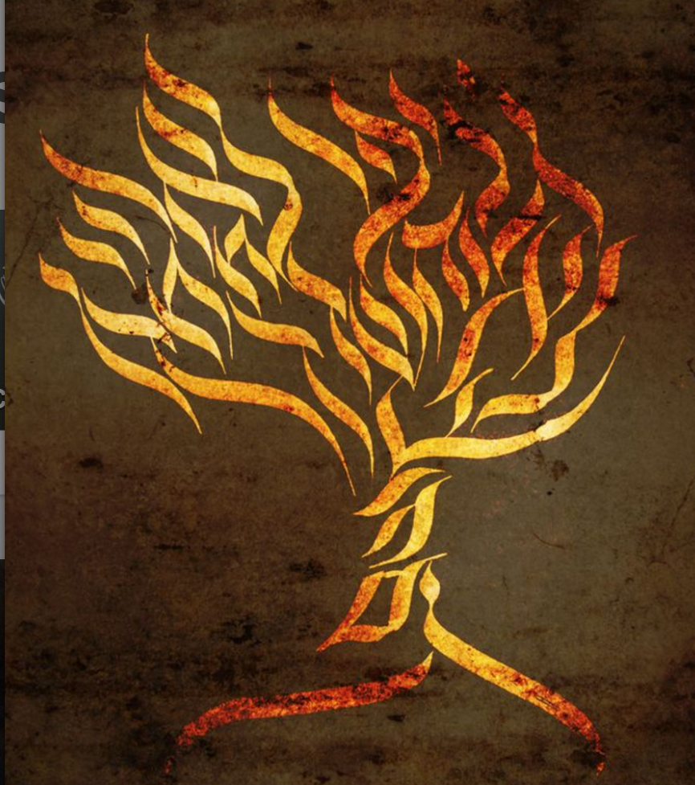

**Excerise: Types of Miracles in Tanach**

*Break into groups and look up the following references – how would you catergorize these miracles? Share your results.*

Exodus 4:1-7

Exodus 14:21

Exodus 19:14-25

Numbers 16:31-35

II Kings 4

II Kings 3: 13-18

I Kings 17

**Exercise: Seeing**

**Leading Idea: Seeing and Hearing**

The difference between *hearing* and *seeing* is an important one – both literally and the way we use these terms metaphorically (phrases like "I see what you mean" and the notion of *insight*). In this narrative God *sees* (Moshe, the israelites’ plight) and *hears* (Moshe, the Israelites plight), and Moshe *sees* (the bush, the angel, the task, potential problems.) and *hears* (God, the task). Yet in what ways are things seen and heard? Are there different ways of seeing and hearing present? What is the relationship between them? Is Moshe’s ability to see in an *attentive* way part of what singles him out? Seeing here also connects with a number of the texts on Miracles (in particular, Heschel, Einstein, Exodus Rabbah.)

What does the word "see" or “seeing” mean in each of these phrases?

1. "It is such a clear night, I can see a lot of stars"
2. “See that you keep these in the correct order”
3. "Seeing is believing"
4. "See, I told you so!!"
5. “When you mention summer, I see the beach and sand in my mind”
6. “He always sees the best in people”
7. “You are just not willing to see it my way!”
8. “Don’t worry, I have enough money to see me through”
9. “Why do you only see her faults?”
10. “Seeing as you are already up, can you please pour me a glass of water?"
11. "I see what you mean. I hadn't thought of it like that"
12. “The last 10 years have seen a sweeping revolution in IT support."
13. “I want to see how she handles this on her own.”
14. “I’ll see to that”
15. “Please see the guests to the door”

Below are some possible ways of understanding the use of the word ‘see’. Can you match the meanings below with the phrases above?

*(a) observe (b) imagine (c) take note*

*(d) consider the fact that (e) understand (f) perceive*

*(g) accompany (h) comprehend (i) gain insight*

*(j) recognize (k) pay attention (l) take care of*

*(m) visualize (n) experience (o) -------------------*

***Return to look at Exodus 3, 1;16 – the word ‘see’ is used many times - which senses of ‘see’ could be meant on each of these occasions? How do different meanings of ‘see’ change how we understand the passage?***

**Discussion Plan: Seeing and Hearing**

*In each case, make sure to explain your answers / responses.*

1. Are there times you are heard but not seen?
2. Are there times you are seen but not heard?
3. Can you look at someone but not see them?
4. Can you hear what someone says but not listen to them?
5. Do you expect friends to see you better than other people? In what ways?
6. Do all your friends see you the same way?
7. Do all your friends hear you the same way?
8. Could someone who disagrees with you be hearing you better than people who agree with you?
9. When we respond to what we hear, do we do it *the same way* as we respond to what we see?
10. Could you see something and respond as if you had heard it? What would this mean?
11. Could you hear something and respond as if you had seen it? What would this mean?

***Return to the questions above – try re-asking them about seeing and hearing God. (e.g.; Are there times when God is heard but not seen? Could you hear what God says but not listen to God? Does it make a difference if you see God as a parent or as a friend? Do you expect God to see you better than other people? In what ways?)***

**Inter-textual exploration of אות**

Using a Tanach, Look up the following references. Is there any difference between the meaning of  ( אות ) in these passages? What do you think the function of the ( אות ) is in each case?  (to show? tell? remind? something else?)

* Shemot 8:18-19 (Plagues)
* Shemot 12:13 (Blood on the doorposts)
* Bereshit 4:15 (Cain and Abel)
* Shemot 31:13 (Shabbat)
* Shemot 31: 17 (Shabbat)

*(Students might like to work in pairs to look up one and then share their findings in the group)*

*What do you think - what kind of “Sign” or* אות *was the burning bush?*