**Bereshit Chapter 9:1-7- בְּרֵאשִׁית**

|  |  |
| --- | --- |
| **א**  וַיְבָרֶךְ אֱלֹהִים, אֶת-נֹחַ וְאֶת-בָּנָיו; וַיֹּאמֶר לָהֶם פְּרוּ וּרְבוּ, וּמִלְאוּ אֶת-הָאָרֶץ. | **1** And God blessed Noah and his sons, and said to them: Be fruitful and become many [people], and fill the earth. |
| **ב**  וּמוֹרַאֲכֶם וְחִתְּכֶם, יִהְיֶה, עַל כָּל-חַיַּת הָאָרֶץ, וְעַל כָּל-עוֹף הַשָּׁמָיִם; בְּכֹל אֲשֶׁר תִּרְמֹשׂ הָאֲדָמָה וּבְכָל-דְּגֵי הַיָּם, בְּיֶדְכֶם נִתָּנוּ. | **2** And the fear of you shall be upon all the wildlife of the earth, and upon all the birds of the heavens, and all that crawl on the soil, and all the fish of the sea - into your hand are they given. |
| **ג**  כָּל-רֶמֶשׂ אֲשֶׁר הוּא-חַי, לָכֶם יִהְיֶה לְאָכְלָה:  כְּיֶרֶק עֵשֶׂב, נָתַתִּי לָכֶם אֶת-כֹּל. | **3** All things crawling about that live, for you shall they be, for eating, as with the green plants, I now give you all of it. |
| **ד**  אַךְ-בָּשָׂר, בְּנַפְשׁוֹ דָמוֹ לֹא תֹאכֵלוּ  .... | **4** however - flesh with its life, its blood, you shall not eat.  **…** |
| **ז**  וְאַתֶּם, פְּרוּ וּרְבוּ; שִׁרְצוּ בָאָרֶץ, וּרְבוּ-בָהּ. | **7** As for you – bear fruit [have children] and be many, swarm the earth and become many on it. |

**Leading Idea: Eating meat**

This text parallels strongly elements of the text in Bereshit 1:28-29. Yet there is a striking difference. In the account of creation in Bereshit, God blesses us as have dominion over all of creation, but only the plant kingdom is given to us to eat for food. In this blessing, God not only gives us plants, but also the animal kingdom as food. In this, it marks a human transition from being herbivores to carnivores. What does this transition signify? What might it say about our relationship to creation and our nature as human beings? To what extent are we what we eat? Does eating flesh make us more violent or is it a release that leads us to be less violent? If we start thinking that it is acceptable to kill animals will we end up thinking it is acceptable to kill people? Both the Jewish textual tradition and philosophical discourse are animated around these questions, offering us multiple responses to that can inform our inquiry.

**Exercise: What do we eat and why / why not?**

|  |  |  |  |  |  |  |  |
| --- | --- | --- | --- | --- | --- | --- | --- |
|  | I eat this | Someone else in my family eats this | Other people in my culture eat this | In the Torah it  says we shouldn’t  eat it | People from  other cultures  I know of do eat it | I don’t think anyone eats this – but it wouldn’t be wrong if they did | No-one should eat this– it is morally wrong |
| Fish |  |  |  |  |  |  |  |
| Dried flowers |  |  |  |  |  |  |  |
| Mushrooms |  |  |  |  |  |  |  |
| Buttons |  |  |  |  |  |  |  |
| Raw eggs |  |  |  |  |  |  |  |
| Animal Hair |  |  |  |  |  |  |  |
| Cats |  |  |  |  |  |  |  |
| Gum |  |  |  |  |  |  |  |
| Pork |  |  |  |  |  |  |  |
| Leftovers |  |  |  |  |  |  |  |
| Strawberries |  |  |  |  |  |  |  |
| Ants |  |  |  |  |  |  |  |
| Mouldy bread |  |  |  |  |  |  |  |
| Human Beings |  |  |  |  |  |  |  |
| Dolphins |  |  |  |  |  |  |  |
| Paper |  |  |  |  |  |  |  |
| Someone else’s half eaten sandwich |  |  |  |  |  |  |  |

**Discussion Plan: Deciding what we eat**

1. Is there any kind of food that you personally choose not to eat? Why?
2. If there are foods you like to eat, why do you like them?
3. If there are foods you don’t like to eat, why don’t you like them?
4. Can the look of food make it more desirable or less desirable?
5. Do you eat the same things now as you did when you were a baby?
6. Do you think that what you eat affects your health?
7. Do you think that what you eat affects your mood?
8. Is there anything you can know about a person from looking at what they eat?
9. Do you think that what you eat or don’t eat can make you a better person?

**Discussion Plan: Deciding what we *should* eat**

1. Do you think parents should decide what food their pre-school child should eat?
2. Do you think your family should decide what you eat?
3. Are there food you can eat too much of?
4. Are there foods you can eat too little of?
5. Are their kinds of food that it is hard to stop eating once you start?
6. Are there animals you don’t think we should eat because it is wrong to kill them?
7. If you raise an animal and look after it – would it be wrong to eat it?

(Would this be the same if you lived on a farm?)

1. In many ways, animals are like people – is that a reason not to kill them?
2. Think of eating an animal’s eye – yuk! Why does this sound gross?
3. Are there foods (like sushi, pizza, falafel, gefilta fish) that you associate with certain countries or cultures.
4. How much do you think that your culture decides what it is possible for you to eat?



**Activity:**

**Interview two people in your family or community about the following:**

1. Is there any kind of food that you personally choose not to eat?

Why not?

2. Do you think that what you eat affects your health?

3. Do you think that what you eat affects your mood?

4. Is there anything you can know about a person from looking at what they eat?

5. Do you eat meat? Why or why not?

**Leading Idea: Our relationship to animals**

A related issue to that of eating meat concerns our relationship with animals overall. What does Judaism say about our treatment of animals; how we should relate to them and care for them? The source materials relate to this question of our care for animals on the other.

**What does the way we care for animals say about us?**

# Proverbs 12:10 מִשְׁלֵי

יוֹדֵעַ צַדִּיק נֶפֶשׁ בְּהֶמְתּוֹ

A righteous man knows the soul of his animal

You should not sit down to eat

until you have first fed your animals

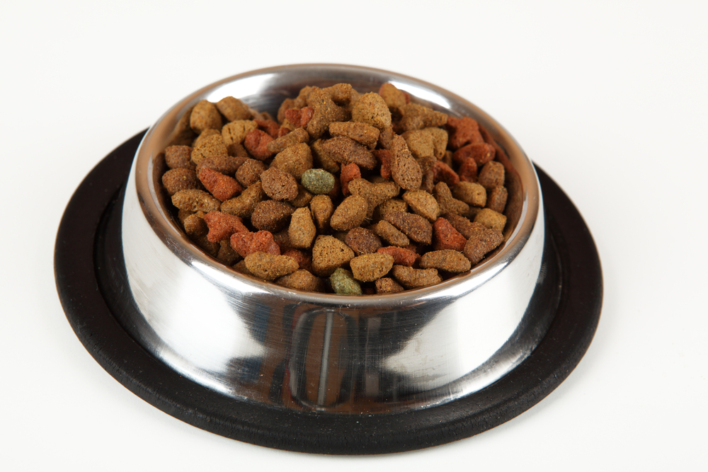

(Talmud, *Berachot*. 40a; *Gittin,* 62a)

You should not buy an animal unless you can guarantee it will have an adequate food supply (Jerusalem Talmud, *Ketubot,* 4:8). 

Moses and David are often described in our tradition as devoted shepherds who gave every animal in their flock personal attention. It was this trait of their personalities that made them worthy in God's eyes of leading the Jewish people.( *Exodus Rabbah* 2.2)

Once, while Moses was tending the flock of his father-in-law, Jethro, one young sheep ran away. Moses ran after it until the sheep reached a shady place, where he found a pool of water and began to drink. When Moses reached the sheep, he said: ‘I did not know you ran away because you were thirsty. Now, you must be exhausted [from running].’ Moses put the sheep on his shoulders and carried him [back to the herd]. God said, “Because you tend the sheep belonging to human beings with such mercy, you shall be the shepherd of My sheep, Israel.”

*Exodus Rabbah 2:2*

**Bereshit Chapter 9:8 -9:17- בְּרֵאשִׁית**

|  |  |
| --- | --- |
| **ח**  וַיֹּאמֶר אֱלֹהִים אֶל-נֹחַ, וְאֶל-בָּנָיו אִתּוֹ לֵאמֹר. | **8** And God said to Noah, and to his sons with him, saying: |
| **ט**  וַאֲנִי, הִנְנִי מֵקִים אֶת-בְּרִיתִי אִתְּכֶם, וְאֶת-זַרְעֲכֶם, אַחֲרֵיכֶם. | **9** 'As for Me, here, I now establish my covenant with you, and with your seed [children] after you; |
| **י**  וְאֵת כָּל-נֶפֶשׁ הַחַיָּה אֲשֶׁר אִתְּכֶם, בָּעוֹף בַּבְּהֵמָה וּבְכָל-חַיַּת הָאָרֶץ אִתְּכֶם; מִכֹּל יֹצְאֵי הַתֵּבָה, לְכֹל חַיַּת הָאָרֶץ. | **10** and with all living creatures that are with you, the fowl, herd-animals, and all the wildlife of the earth with you; with all those going out of the Ark, of all the living things on the earth. |
| **יא**  וַהֲקִמֹתִי אֶת-בְּרִיתִי אִתְּכֶם, וְלֹא-יִכָּרֵת כָּל-בָּשָׂר עוֹד מִמֵּי הַמַּבּוּל; וְלֹא-יִהְיֶה עוֹד מַבּוּל, לְשַׁחֵת הָאָרֶץ. | **11**  I will establish my covenant with you; never again shall all flesh be cut off again by waters of a flood; never again shall there be a flood, to destroy the earth! |
| **יב**  וַיֹּאמֶר אֱלֹהִים, זֹאת **אוֹת**-הַבְּרִית אֲשֶׁר-אֲנִי נֹתֵן בֵּינִי וּבֵינֵיכֶם, וּבֵין כָּל-נֶפֶשׁ חַיָּה, אֲשֶׁר אִתְּכֶם--לְדֹרֹת, עוֹלָם. | **12** And God said: 'This is the sign of the covenant which I set between me and you and all living creatures that are with you, for all ages to come: |
| **יג**  אֶת-קַשְׁתִּי, נָתַתִּי בֶּעָנָן; וְהָיְתָה לְ**אוֹת** בְּרִית, בֵּינִי וּבֵין הָאָרֶץ. | **13** My bow, I set in the cloud, so that it shall serve as a sign of the covenant between Me and the earth. |
| **יד**  וְהָיָה, בְּעַנְנִי עָנָן עַל-הָאָרֶץ, וְנִרְאֲתָה הַקֶּשֶׁת, בֶּעָנָן. | **14** And when I bring clouds over the earth, and the bow is seen, in the clouds |
| **טו**  וְ**זָכַר**ְתִּי אֶת-בְּרִיתִי, אֲשֶׁר בֵּינִי וּבֵינֵיכֶם, וּבֵין כָּל-נֶפֶשׁ חַיָּה, בְּכָל-בָּשָׂר; וְלֹא-יִהְיֶה עוֹד הַמַּיִם לְמַבּוּל, לְשַׁחֵת כָּל-בָּשָׂר. | **15** I will remember my covenant, which is between me and you and all living creatures of all flesh; so the waters shall no more become a flood to destroy all flesh. |
| **טז**  וְהָיְתָה הַקֶּשֶׁת, בֶּעָנָן; וּרְאִיתִיהָ, לִזְכֹּר בְּרִית עוֹלָם, בֵּין אֱלֹהִים, וּבֵין כָּל-נֶפֶשׁ חַיָּה בְּכָל-בָּשָׂר אֲשֶׁר עַל-הָאָרֶץ. | **16** When the bow will be, in the cloud; I will see it, and remember the covenant between God and all living creatures - all flesh that is on the earth |
| **יז**  וַיֹּאמֶר אֱלֹהִים, אֶל-נֹחַ:  זֹאת אוֹת-הַבְּרִית, אֲשֶׁר הֲקִמֹתִי, בֵּינִי, וּבֵין כָּל-בָּשָׂר אֲשֶׁר עַל-הָאָרֶץ.  {פ} | **17** And God said to Noah: 'This is the sign of the covenant which I have established between me and all flesh that is upon the earth.' |
| **יח**  וַיִּהְיוּ בְנֵי-נֹחַ, הַיֹּצְאִים מִן-הַתֵּבָה--שֵׁם, וְחָם וָיָפֶת; וְחָם, הוּא אֲבִי כְנָעַן. | **18** And the sons of Noah, that went out from the Ark, were Shem, and Ham, and Japheth; and Ham is the father of Canaan. |

**Leading Idea:**

**Establishing (**מֵקִים **) , remembering (**לִזְכֹּר**) and remembering in the future** (**זָכַר**ְתִּי)

In Verses 9:8-17 God turns his attention from Noah to himself. “As for me…” Within this passage he reflects on the act of *establishing* a covenant and remembering it – that is *maintaining* a convenant (keeping it over time), and the intention to keep it in the future (I will remember). God also reflects on the ‘sign’ (אות) , or rainbow, as *representing* the covenant (as a sign of the covenant), as a way of *showing us* of his intentions (it stands as a sign between me and you), and as a way of *reminding himself* of his covenant. These exercises and discussion plans explore these subtle yet very powerful distinctions.

**Exercise: starting something and remembering to keep it going once it is started**

*Is there a difference between these things, if so, what is the difference?*

* Setting a rule that says "do not enter the room without knocking"
* Remembering to keep the rule that says "do not enter the room without knocking"
* Starting a friendship
* Keeping that person as a friend
* Earning a name for being fair
* Remembering to always be fair
* Keeping a name for being fair once you have it

**What is the difference between…**

* Putting a sign on the door to *let visitors know* that they can't enter without knocking.
* Putting a sign on the door to *remind* visitors that they can't enter without knocking.
* Putting a sign on the door to *remind yourself* that you shouldn’t let visitors in unless they have knocked on the door first.

**When might you need to post each of these signs?**

**Sources**

Is there any difference between the meaning of ( אות ) in the following passages? What is the function of the ( אות ) (to show? tell? remind? something else?)

* Read together Shemot 12:13 (God telling the Israelite to mark their door frames during the plagues)

Discuss the ways in which this is similar and different from the rainbow. (for example: Who is doing the actions? Is this a case of establishing or reminding? Is this tohelp the Israelites also remember that they will be safe form God’s action - is this the same as the rainbow?)

**Drama Activities**

1. Divide into small groups – half the groups will work with the Exodus text and half the groups with the in the rainbow text – they should create a skit that shows what they think putting the sign up (on the door, in the sky) is about in light of their discussion.

2. Divide into small groups – create a skit that shows how you understand the rainbow text in light of some of the distinctions you explored in your community of inquiry / in these discussion plans

**Leading Idea: Caring for our world**

This section of text about the Keshet comes after the flood – after God in his anger almost completely destroys the world. The Keshet is a reminder to God to avoid global destruction in the future. This raises a larger question about our relationship to the world and our care for it. The following poem can invite discussion around our sensory experiencing of the world and our care for it. You might like to create your own poem that draws on the way your students’ own experiences of connecting to the world through their senses.

***Look upon This Land*** *Look upon this land—  
Touch it.  
Sand under your bare feet,  
The squish of mud,  
Silky coat of cat,  
Soft rose petals,  
A smooth round rock,  
Rain on your face.  
  
Touch it with your eyes.  
Cherry trees blossoming pink,  
Lake of blue and summer sky,  
The green of life,  
Purple grapes and apples red,  
Moon rising yellow,  
Orange sun going down.  
  
Touch it with your ears.  
Splatter of rain,  
Crack of thunder,  
Wind whispering,  
Birds singing,  
The crying of babies and puppies,  
Kittens and ducklings.*

*Touch it with your nose.*

*Pine-scent of woods, lilacs blooming,*

*new-mown grass, smoke of chimneys,*

*strawberries in the sun.*

*Touch it with your tongue.  
Lick of sugar,  
Tang of lemon, ginger, or spice,  
Bite of cold snow,  
Gulp of pure water.  
  
Look upon this land—  
Touch it.  
Touch it in every way you can,  
For this land is part of you,  
And you are part of it.*

*Given into your care is this earth.  
See how beautiful it is.  
Be careful not to spoil it,  
For if you destroy the world,  
There will be no one after you to restore it.  
(Kohelet Rabbah 1 on Ecclesiastes 7:13)*

*(Molly Cone, Listen to the Trees [New York: UAHC Press, 1995], pp. 42-43)*

**Activity**

Create your own poem that draws on the way your students’ experience their connection to the world through their senses.

**......................................................**

When in your war against a city you have to lay siege on it in order to capture it, you must not destroy its trees, wielding the ax against them. You may eat of them, but you must not cut them down. Are trees of the field human, able to move into the city you are seeking to capture? Only trees which you know do not yield food may be destroyed... (Deuteronomy 20:19-20)

While the verses themselves deal specifically with cutting down trees during war, the Sages extended their meaning to cover all forms of wasteful destruction. They taught that anyone who deliberately wastes our resources, either natural or man-made, violates the law.

*Harriet M. Levine, Woodlands Community Temple, White Plains, NY*

[*http://www.reformjudaism.org/learning/torah-study/shoftim/protect-trees-protect-our-world*](http://www.reformjudaism.org/learning/torah-study/shoftim/protect-trees-protect-our-world)