
Bereshit 12:1-9 (Lech L’cha)
1. God said to Avram, "Go, take yourself
from your land
and from where you were born,
and from your father's house
to the land that I will let you see:

2. I will make you a great nation
And I will bless you,
I will make your name great.
And be a blessing.

3. I will bless those people who bless you
And those that curse you, I will curse;
And all the families of the earth shall find
blessing through you [by way of you."

4. Avram went, as God had told him,
and Lot went with him.
And Avram was seventy-five years old
when he went out of Haran.

5. Avram took Sarai, his wife,
and Lot, his brother's son,
and all their belongings that they had gained,
and the people they had made their own
in Haran; and they went to go to the land of
Canaan.

Leading Idea: Thinking about Journeys and Journeying
The books of Bereshit and Shemot are full of journeys. Several ideas are explored here that prepare students for the pieces of narratives that they will encounter. In this regard the first set of discussion plans and activities can act as induction exercises to ‘journeying’ in general, as well as being used to explore more deeply questions students raise. Attention is drawn here to two aspects of journeying that can prepare students for thinking about this Parashah.

- The meaning of journeying – what makes something a journey and what does journeying involve?

- The act of going on a journey – what do the things people take on a journey tell us about the kind of journey they are on?

Discussion Plan: Journeys and Journeying
- Does a journey need to have a place of departure? Explain
- Does a journey need to have a set destination? Explain
- Are there different kinds of journeys? What makes them different?
- If I start walking but end up back where I started from, have I taken a journey?
- Can I end up in a different place without taking a journey?
- Can I take a journey without moving at all?
- Can journeys be good or bad, or is it the things that happen on them that are good or bad?
- Could a trip to the end of the street become a journey?
- Is there a difference between a journey I take on my own and a journey I take with others? If so, what are some of the differences?
- In what ways might a journey change you?
- In what ways might a journey surprise you?
- Is there a difference between a journey someone instructs you to take, and a journey you choose to take? If so, what are some of the differences?
- Explore this image of journeying and its possible meanings.

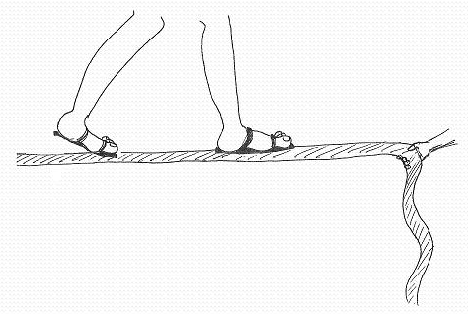

מ. גלסר

Exercise: Journeys

This exercise strengthens our reasoning skills by asking us to reason toward the best explanation. If someone sets out with these items (amongst others) on a journey, what might you infer about:
- Where they might be going;
- What they might be planning to do;
- How they plan on getting there.

- Sunscreen, thick boots, compass, a water bottle and a back pack with a box of worms
- Shorts and T-shirt, a leather jacket, gloves, goggles, a beach towel and book.
- A can of gasoline, bottle of water, spare tire, MP3 player, and horse in a trailer
- A 50ft rope, pegs, hammer, hard helmet, 4 wheel drive
- Iced chocolate cake, change of clothes, a CD wrapped in wrapping paper, train schedule, candles

As a variation, in pairs prepare to tell the story of this journey to the rest of the group.

Returning to the Lech l’cha text – what do we know about what Avram took with him? What might we infer from this about his thoughts about the journey he is making?


http://www.openfotos.com/view/steps-in-desert-4510

Leading Idea: Different Meanings of Lech L’cha
‘Lech l’cha’ is generally taken as an expression meaning “Go forth”. But this isn’t the only way of reading it. While Lech l’cha on its own is a command (like sit! or stop!), lech on its own means ‘go’ and l’cha’ on its own generally means ‘to you’. What might these mean when put together?
In this unit we explore the following different readings of the phrase ‘Lechl’cha’.
1. Go forth: move forward, leave where you are (pick up your tent and go pitch it elsewhere)

2. Go for yourself: for your own benefit, for your own material good (financial, social, etc)

3. Go to yourself: discover yourself - go to greater self-understanding (as an inner existential journey - become aware of who you currently are, get in touch with yourself)
4. Go to the person you will become: Go toward you’re the person you will one day be (eg, your ‘better self’ or your destiny, or the person you are striving to be – as in the joke that has a mother describing her 6yr old son as ‘my son the doctor’) – this captures the idea that we are all on a journey of self-formation, and we become who we are over time.
Each of these offers a different understanding of Avram’s journey. The resources here both provide voices from within our tradition that speak to these interpretations and resources for students to apply the distinctions in their own lives and thus to come to internalize the different meanings as resources for making sense of different kinds of ‘Lech!’ in their own lives..

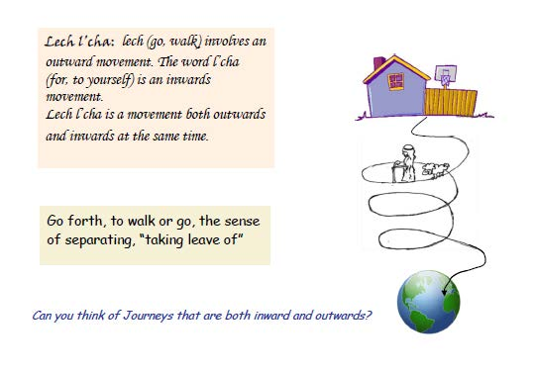
Secondary source

Exercise: Different Meanings of “Lech L’cha”
Read the sentence on the left – which kind of “Go Forth!” do you think is invoked here? You can mark more than one, but make sure you can explain what you mean in each case. If you mark more than one, explain what it would mean to ‘go’ for each one you marked (eg, going camping might be ‘go forth’ because going to camp means you are moving geographically, but it also may be ‘go to yourself’ because when you are camping you discover you are now capable of doing things that you never would have thought you could do).

 | Go!  Leave where you are for somewhere else | Go for yourself!  Ffor your own benefit – Eg, financial or physical benefit) | Go to your yourself  Getting to know yourself better | Go - to the person you will become Growing up,  Becoming a better person
Kate, age 6: “I’m excited about starting a new school, I’m going to learn so many new things.”
Eli, age 5: “we went to the lake for the first time I thought I would be scared to go in the water but I learned that I really liked it!”
Zaitlan, age 8: “Going to summer camp last year was my first time away from home – I really became more confident and independent.
Ronnie, age 7: “We are going to visit our grandparents in Texas – I am really excited”
Kate: “I’m going to miss you when you leave, but I know the job in Boston pays a higher salary.”
David, age 9: “Once a week after school I go with my mum to the home where my grandparents live. I help them to go down to the dining room and sometimes I sing for them because they like that.

Go back to the Biblical text – if we view Avram’s journey through each of these lenses, how might we understand the meaning and significance of his journey ?

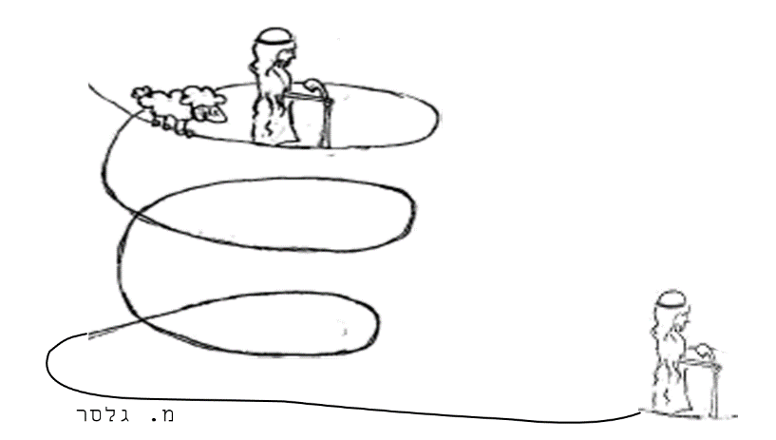

Exercise: Different Journeys
Where do you think they are going? What might be the purpose of their journey? Which kind of “Lech L’cha’ are they on








Leading Idea: Circles of attachment. (Bereshit 12:1)

When God tells Avram “Lech lecha” he mentions three kinds of leaving:
- Leave your country
- Leave your birthplace
- Leave your father’s house

Several scholars have noted that it seems strange to list the circles of attachment in this order. The text from Nechama Leibowitz and the commentary Haktav Vehakabala both offer an interpretation for this.

This next set of exercises and discussion plan explore these different ‘layers of leaving’.

Exercise: Circles of Attachment
What in your life are you most attached to? Think of your home – if you were to leave home, what would be most difficult to leave behind? What not as difficult? Draw three circles. In the centre put the thing it would be most difficult to leave, then move out in the circles with things that would be less difficult to leave (from hardest to less hard). Pick a different community you are part of (school? sports team?) – what would be hardest to leave behind if you were leaving that community?

Home


Nehama Leibowitz: from Studies in Bereshit, pp.113
"לֶךְ-לְךָ מֵאַרְצְךָ וּמִמּוֹלַדְתְּךָ וּמִבֵּית אָבִיךָ"
“get you out of your country, and from your birthplace, and from your father’s house…”
scholars have spoken about the unusual order of ‘leaving’ here. The verse should have read, in the ordinary way: "מבית אביך, ממולדתך ומארצך" (from your father’s house, your birthplace and from your country.”) This is the logical sequence, since a person first leaves home, then his place of birth and then his country.

The commentary הכתב והקבלה (Haktav Vehakabala)* suggests that there we are referring to a spiritual rather than physical withdrawal, beginning with more distant connections and ending with the most personal. Leaving your place of birth is not so hard as cutting the connection to your family. Fir st, therefore, Abraham was told to cut his connection with his country, then his city and finally the most intimate bond, that of home.

*Haktav Vehakabala: Was written by Rabbi Yaakov Tzevi Mecklenburg, a German Jewish scholar of the 19th century. Rabbi Mecklenburg served as Rabbi of Koenigsburg, East Prussia for 35 years (1831-65). Haketav Vehakabbalah was first published in 1839.

Nehama Leibowitz -1905-1997, was a famous Israeli Bible scholar who developed a particular style of Bible study that was very popular around the world.
Picture; www.lookstein.org/nechama_biography.htm

Discussion Plan: Leavings

- Do we all have to ‘leave home’ in order to grow up? Explain.
- Abram took his extended family with him – so what was he really leaving behind?
- If you go away but you still think about people a lot, and text them/e-mail them, have you left them behind?
- If you still hear them speaking to you – telling you what to do – have you left them behind?
- In growing up – do you think the important thing is what you are leaving, or what you are heading towards?
- Are you connected to places as well as people? Describe one of those places.
- Do you think that places are tied to who you are in the same way as people are? Explain.
Leading Idea: Blessings and Curses
In this passage, God makes three kinds of claims regarding how Avram will be blessed:
- I will bless you
- You shall be a blessing
- All the families of the earth shall bless themselves by/through you

What is a blessing? What does it mean ' to be blessed'? What might it mean to regard yourself blessed by the presence of someone else?

How might giving or receiving a blessing be different from being a blessing? Or being blessed? Whereas the activity of 'giving or receiving blessings suggests a kind of transaction - with something being passed on from one person to another, the state of 'being a blessing' and ‘being blessed’ suggests some state of being – some inner active quality of a person. Here there is an interesting question - is ‘blessing’ being used transitively or intransitively? There is a difference between verbs used non-transitively (like “she is standing over there” OR “she Is crying” and transitive verbs (like “Sam was hitting the pillow”). Whereas non-transitive verbs like standing and sitting don’t have any direct object, you can only be ‘hitting’ if there is some object that directly receives your action (to hit you have to be hitting something).

A lot of verbs can be used both ways – and this seems to be the case with blessing. In this way ‘being blessed’ might grammatically be more like ‘being kind’ than ‘being happy’ - to say someone is being kind is to point to the way they interact with others and the world – it is doubtful you could be kind if you were totally alone on a desert island. (where there was no-one/nothing to be kind toward). While being happy is an inner state.

Another way of thinking about “being a blessed to others” might be the sort of thing that we might have in mind when we say of someone: “she is such a calm person, when she is here she has a calming influence on the whole room.” (or spiritual person, or agitated person – the point being their state of being has an impact on their environment). We might also think of ways that we are blessed because of the presence of other people in our lives.

How might these meanings shed light on the text?

In addition to blessing Avram, God says he will bless all who bless Avram and curse all those who curse him. This not only suggests that people (as well as God) are capable of blessing and cursing – but opens up the moral question of what it means for God to act toward others according to how others treat Avram. What are we doing when we bless and curse people? Is it just another way of wishing them something (for instance, good or bad luck?). Can the idea of giving or receiving a blessing have significance even if you don't believe in ' a God who blesses or curses?

In Summary:
We might see being a blessing / being blessed as :
      - An Inner Quality or state (non-transitive)
  - Could just be in you
  - Could also radiate out from you (like a person who is calm can make the room calm by their presence – the person impacts their environment)
- A quality you have that expresses itself outward to an object (like hitting – where you are hitting something)
  - Something you pass on to someone else through the act of blessing them
  - Through your interactions with others, their lives change in a substantial way (eg., they become a great nation)

We might understand blessing as:
- Wishing or hoping
- Something only God can give or something people can also give, or both.
- the person being blessed is the one being changed, or the person giving the blessing is the one being changed, or both.
- Having meaning only if you believe in God or having meaning even if you don’t believe in God?

These are fine (and somewhat complex) distinctions, but getting the students to think about these ideas is guided by different discussion plans – for example, the discussion plan on “giving and receiving blessings’ explores the transitivity of ‘Blessing’. .
Discussion Plan: Being Blessed
- Can a person’s life be blessed? If so, did it need someone to bless it? Explain,
- Can a person be blessed with good health? If so, what does this mean?
- Can we be a blessing to our parents? If so, what does this mean?
- Can a day be blessed? Explain
- Is there a difference between ‘being blessed’ and ‘receiving a blessing’?

Discussion Plan: Everyday uses of the term “Bless”
What is meant in each of these cases?
Does “Bless” mean the same thing in each case?

“Sam was blessed with children”
“Sam blessed his children”
“Sam’s children thought they were blessed to have him as a father”
“Sam was blessed with kindness”
“Sam saw kindness as a blessing”
Sam said to his friend: “Being late to the party is a blessing in disguise”

Discussion Plan: Giving and receiving blessings
  - Can anyone receive a blessing?
  - Can anyone give a blessing?
  - Can you give a blessing without realizing you have done so?
  - Can you ask for a blessing? If so, what do you think happens when you are ‘being blessed’?
  - Can you demand or force someone to bless you?
  - Can you believe in blessings without believing in curses?
  - Can you believe in blessings without believing in God?
  - What blessing would you wish for?\What blessing would you like to give to someone else?

What is the meaning of “blessing”?

- If I bless you saying “May God grant you long life”, is that the same as wishing you a long life?
- If I bless you saying “May God grant you long life”, is that the same as hoping you will have a long life?
- Can people give blessings, or only God? If people can give them, do you think there is a difference between a blessing given by God and a blessing given by a person? Explain.
- Can you ‘give a blessing’ without blessing someone /something?
- Is there a difference being blessed and being a blessing?
- If a quality of ‘being hot’ is that the thing that is hot gives off heat – then is it possible that a quality of ‘being blessed’ is that the thing that is blessed gives off blessings?
- Could you ‘be a blessing’ if you had no effect on those around you?
In Verse 3 God says:
וְנִבְרְכוּ בְךָ כֹּל מִשְׁפְּחֹת הָאֲדָמָה
And all the families of the earth
shall find blessing through you.

What do you think this means?

Activity:
This is the way Cohenim hold their hands when giving the priestly blessing – the fingers form a Shin to represent Shaddai (God’s name.) Can you hold your hands this way? Look up the blessing Bamidbar 6:23–27.

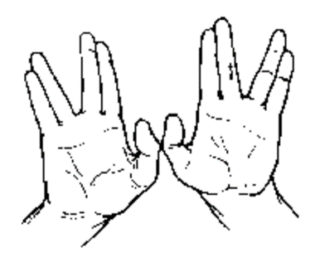

Image from: http://ggorelik.narod.ru/LeHaim_W/LeHaim_W1.htm By Kleuske - Own work, CC BY-SA 3.0, https://commons.wikimedia.org/w/index.php?curid=20497346

Divine and Human blessings.

Which of these blessings are asked for and which given without asking? Do you think this makes a difference? Who or what are the blessings directed toward – how does it change the thing being blessed?

Divine Blessings
Does the blessing recognize something (a quality) that is already present or does it create something new? What is the meaning of the blessing? What is intended by the blessing?

- God blesses Avram - Bereshit 24:1
וְאַבְרָהָם זָקֵן בָּא בַּיָּמִים וַיהֹוָה בֵּרַךְ אֶת אַבְרָהָם בַּכֹּל.

- Yaakov demands a blessing from the man-angel – Bereshit 32:25-27
וַיֹּאמֶר שַׁלְּחֵנִי כִּי עָלָה הַשָּׁחַר וַיֹּאמֶר לֹא אֲשַׁלֵּחֲךָ כִּי אִם בֵּרַכְתָּנִי...

- God blesses the 7th day – Bereshit 2:3
וַיְבָרֶךְ אֱלֹהִים אֶת-יוֹם הַשְּׁבִיעִי, וַיְקַדֵּשׁ אֹתוֹ ...

Human Blessings
Does the blessing create something new or recognize something (a quality) that is already present? Is the blessing freely offered? What is intended by the blessing?

- Yitzak blessing Yaakov - Bereshit 27:30
וַיְהִי כַּאֲשֶׁר כִּלָּה יִצְחָק לְבָרֵךְ אֶת יַעֲקֹב

- Yakov blesses Yoseph – Bereshit 48:15
וַיְבָרֶךְ אֶת יוֹסֵף וַיֹּאמַר

- The blessing we recite over food
בָּרוּךְ אַתָּה יְהוָה אֱלהֵינוּ מֶלֶךְ הָעולָם ...
- Parents bless their children
יְבָרֶכְךָ יְהוָה וְיִשְׁמְרֶךָ

Activity: Blessing the Children
This custom is a nice way of bringing gratitude and spirituality into your family on Shabbat and at other special occasions. There are different customs as to when the blessing is recited. Some families bless their children immediately before or after Kiddush. Others prefer to bless just after lighting the Shabbat candles. Usually the person giving the blessing places one or both hands on the child's head. Some parents bless each child in succession, others bless all of the girls together, and all of the boys together, while other families have developed their own rituals around this practice.

In Pairs, take it in turns to give the blessing one to another – do it with Kavanah (focused intentionality). What did it feel like to give the blessing? What did it feel like to receive the blessing? (Physically, how did you experience it? How did the relationship with the other person feel during this experience?)
The words of the blessing are taken from the priestly blessing (Bamidbar 6:24-26) and traditionally the introduction is constructed differently according to the gender of the person being blessed. Some people like to ‘mix this up’ and include both male and female figures in blessing their child.
For males:
יְשִׂימְךָ אֱלהיִם כְּאֶפְרַיְם וְכִמְנַשֶּׁה
May you be like Ephraim and Menashe.

For females:
יְשִׂימֵךְ אֱלהיִם כְּשָׂרָה רִבְקָה רָחֵל וְלֵאָה
May you be like Sarah, Rebecca, Rachel, and Leah. .

For both genders, the rest of the blessing is:
יְבָרֶכְךָ יְהוָה וְיִשְׁמְרֶךָ
יָאֵר יְהוָה פָּנָיו אֵלֶיךָ וִיחֻנֶּךָּ
יִשָּׂא יְהוָה פָּנָיו אֵלֶיךָ וְיָשֵׂם לְךָ שָׁלום

May God bless you and guard you.
May God show you favor and be gracious to you.
May God show you kindness and grant you peace.

------------------------------------------------------------------------------------

Discussion Plan: Giving and Receiving Curses
- Can you be cursed with bad health? If so, what does this mean?
- Can a day be cursed? Explain
- Can a person’s life be cursed? If so, did it need someone to curse it? Explain,
- Can we be a curse to our parents? To our teachers? If so, what does this mean?
- If I curse you by saying “May all your friends abandon you” is that the same as wishing that all your friends would abandon you?
- Can people give curses or only God? If people can give them, do you think there is a difference between a curse given by God and a curse given by a person? Explain.
- Can having someone curse you ever be a good thing?
- Does giving a curse guarantee that the content of the curse will happen or come true?
- Can you believe in blessings without believing in curses?
- Can you believe in curses without believing in God?

[N.B. the discussion plans above can be adapted to look at curses if that is the question / interest students raise.]

