**Bereshit Chapter 9:1-7- בְּרֵאשִׁית**

|  |  |
| --- | --- |
| **א**  וַיְבָרֶךְ אֱלֹהִים, אֶת-נֹחַ וְאֶת-בָּנָיו; וַיֹּאמֶר לָהֶם פְּרוּ וּרְבוּ, וּמִלְאוּ אֶת-הָאָרֶץ. | **1** And God blessed Noah and his sons, and said to them: 'Be fruitful and multiply [be many], and fill the earth. |
| **ב**  וּמוֹרַאֲכֶם וְחִתְּכֶם, יִהְיֶה, עַל כָּל-חַיַּת הָאָרֶץ, וְעַל כָּל-עוֹף הַשָּׁמָיִם; בְּכֹל אֲשֶׁר תִּרְמֹשׂ הָאֲדָמָה וּבְכָל-דְּגֵי הַיָּם, בְּיֶדְכֶם נִתָּנוּ. | **2** And the fear of you and the dread of you shall be upon all the wildlife of the earth, and upon all the fowl of the heavens, and all that crawl on the soil, and all the fish of the sea - into your hand are they given. |
| **ג**  כָּל-רֶמֶשׂ אֲשֶׁר הוּא-חַי, לָכֶם יִהְיֶה לְאָכְלָה:  כְּיֶרֶק עֵשֶׂב, נָתַתִּי לָכֶם אֶת-כֹּל. | **3** All things crawling about that live, for you shall they be, for eating, as with the green plants, I now give you all of it. |
| **ד**  אַךְ-בָּשָׂר, בְּנַפְשׁוֹ דָמוֹ לֹא תֹאכֵלוּ. | **4** however - flesh with its life, its blood, you shall not eat. |
| **ה**  וְאַךְ אֶת-דִּמְכֶם לְנַפְשֹׁתֵיכֶם אֶדְרֹשׁ, מִיַּד כָּל-חַיָּה אֶדְרְשֶׁנּוּ; וּמִיַּד הָאָדָם, מִיַּד אִישׁ אָחִיו--אֶדְרֹשׁ, אֶת-נֶפֶשׁ הָאָדָם. | **5** And for your blood, of your own lives, I will demand satisfaction – from all wild animals I will demand it, and from humankind, from every man regarding his brother, will I demand satisfaction for human life. |
| **ו**  שֹׁפֵךְ דַּם הָאָדָם, בָּאָדָם דָּמוֹ יִשָּׁפֵךְ:  כִּי בְּצֶלֶם אֱלֹהִים, עָשָׂה אֶת-הָאָדָם. | **6** Whoever now sheds human blood, for that human shall his [own] blood be shed, for in Elohim’s image he made humankind. |
| **ז**  וְאַתֶּם, פְּרוּ וּרְבוּ; שִׁרְצוּ בָאָרֶץ, וּרְבוּ-בָהּ. | **7** As for you – bear fruit and be many, swarm the earth and become many on it |

**Leading Idea: Eating animals.**

This text parallels strongly elements of the text in Bereshit 1:28-29. Yet there is a striking difference. In the account of creation in Bereshi, God blesses us as have dominion over all of creation, but only the plant kingdom is given to us to eat for food. In this blessing, God not only gives us plants, but also the animal kingdom as food. This marks a human transition from being herbivores to carnivores. Whether we should eat meat is a contentious issue. Before delving into this issue it might be helpful to slow down and spend time reflecting on how we decide what counts as food and how we decide which foods we will eat. The issue is more complex than merely deciding between “meat or not meat”. The discussion plans and exercises here explore our relationship to food, how what we eat might affect us, and how we decide – culturally, religiously, and morally – the boundaries to what we choose to eat.

While the text now states we have permission to eat meat, there are *distinctions* and *limits* here as well – we can eat flesh, but not blood, and we will be held accountable for killing another human being. What does this transition signify? What might it say about our relationship to creation and our nature as human beings? To what extent are we what we eat? Does eating flesh make us more violent or is it a release that leads us to be less violent? If we start thinking that it is acceptable to kill animals will we end up thinking it is acceptable to kill people?

Both the Jewish textual tradition and philosophical discourse are animated around these questions, offering us multiple responses to that can inform our inquiry.

**Discussion Plan: Deciding what we eat**

1. Is there any kind of food that you personally choose not to eat? Why?
2. What makes certain foods attractive to you - such that you want to eat them?
3. What makes certain foods unattractive to you – such that you don’t want to eat them?
4. Do you eat the same range of food now as you did 5 years ago?
5. Do you eat the same range of food now as you did when you were a baby?
6. Can people’s diets change, even when they are adults? Can you give an example?
7. Can you look at what someone eats and draw any conclusion about their values?
8. Do you think that what you eat or don’t eat can make you a better person?

**Discussion Plan: The connection between who we are and what we eat.**

1. If a person likes rare or raw meat, do you think they are likely to be more aggressive than someone who likes their meat well done? Why / Why not?
2. If a person likes sweet things, do you think they are likely to have a sweet nature? Why / why not?
3. Is there such a thing as ‘comfort food’? What does this mean?
4. Is there such a thing as “Junk food”? What does this mean and why do we eat it?
5. Is there such a thing as “soul food”? What does this mean?
6. Do you think that what you eat affects your health? If so, give some examples.
7. Do you think that what you eat affects your mood? If so, give some examples.
8. If you eat healthy food are you likely to be more healthy? Why / why not?
9. In what ways is what we eat connected to our culture?
10. Do you think that someone who eats according to the practices of their culture has a stronger cultural identity than someone who does not? Why/why not?

**Exercise: What do we eat and why / why not**

|  |  |  |  |  |  |  |  |
| --- | --- | --- | --- | --- | --- | --- | --- |
|  | I eat this | Someone else in my family eats this | Other people in my culture eat this | In the Torah it  says we shouldn’t  eat it | People from  other cultures  I know of do eat it | I don’t think anyone eats this – but it wouldn’t be wrong if they did | No-one should eat this– it is morally wrong |
| Fish |  |  |  |  |  |  |  |
| Dried Pineapple |  |  |  |  |  |  |  |
| Mushrooms |  |  |  |  |  |  |  |
| Beef |  |  |  |  |  |  |  |
| Golf balls |  |  |  |  |  |  |  |
| Raw eggs |  |  |  |  |  |  |  |
| Lamb |  |  |  |  |  |  |  |
| Animal Hair |  |  |  |  |  |  |  |
| Blood sausage |  |  |  |  |  |  |  |
| Monkeys |  |  |  |  |  |  |  |
| Cats |  |  |  |  |  |  |  |
| Gum |  |  |  |  |  |  |  |
| Pork |  |  |  |  |  |  |  |
| Elephants |  |  |  |  |  |  |  |
| Leftovers |  |  |  |  |  |  |  |
| Strawberries |  |  |  |  |  |  |  |
| Ants |  |  |  |  |  |  |  |
| Human Beings |  |  |  |  |  |  |  |
| A leather shoe |  |  |  |  |  |  |  |
| Dolphins |  |  |  |  |  |  |  |
| Mice |  |  |  |  |  |  |  |
| Paper |  |  |  |  |  |  |  |
| Someone elses half eaten sandwich |  |  |  |  |  |  |  |
| A pen |  |  |  |  |  |  |  |



**Activity:**

**Interview two people in your family or community about the following:**

1.Is there any kind of food that you personally choose not to eat? Why?

2. Do you think that what you eat affects your health?

3. Do you think that what you eat affects your mood?

4. Do you think you can look at what someone eats and draw any conclusion about their lifestyle? Their values?

5. Do you think that what you choose to eat or not eat can makes you a better person?

6. Do you eat meat? Do you think this affects the kind of person you are?

7. In the account of creation God blesses us and tells us and gives us all seed bearing plants to eat. In Noah, after the flood he tells he blesses us again, but this time he also allow us to eat meat. Why do you think God changes his blessing? Do you think we should eat meat?

**Discussion Plan: Deciding what we *should* eat**

1. Do you think parents should decide what food their pre-school child should eat?
2. Do you think your family should decide what you eat now?
3. Are there food you can eat too much of?
4. Are there foods you can eat too little of?
5. Are their kinds of food that it is hard to stop eating once you start?
6. If a species is endangered, should people continue to eat it? (even if it acceptable to eat it)
7. Are there animals you don’t think we should eat because it is wrong to kill them?
8. If you raise an animal and look after it – would it be wrong to eat it?

(Would this be the same if you lived on a farm?)

1. In many ways, animals are like people – is that a reason not to kill them?
2. Think of eating an animal’s eye – disgusting? Why does this disgust you?
3. To what extent do you think that your culture decides what it is possible for you to eat?
4. To what extent do you think the Torah should guide what you eat and what you don’t?
5. Do you think that if we think it is OK to kill animals we are more likely to think it is ok to

kill people?

1. Can you love animals and eat meat?

**To Adam: To Noah:**

|  |
| --- |
| **א**  וַיְבָרֶךְ אֱלֹהִים, אֶת-נֹחַ וְאֶת-בָּנָיו; וַיֹּאמֶר לָהֶם פְּרוּ וּרְבוּ, וּמִלְאוּ אֶת-הָאָרֶץ. |
| **ב**  וּמוֹרַאֲכֶם וְחִתְּכֶם, יִהְיֶה, עַל כָּל-חַיַּת הָאָרֶץ, וְעַל כָּל-עוֹף הַשָּׁמָיִם; בְּכֹל אֲשֶׁר תִּרְמֹשׂ הָאֲדָמָה וּבְכָל-דְּגֵי הַיָּם, בְּיֶדְכֶם נִתָּנוּ. |
| **ג**  כָּל-רֶמֶשׂ אֲשֶׁר הוּא-חַי, לָכֶם יִהְיֶה לְאָכְלָה:  כְּיֶרֶק עֵשֶׂב, נָתַתִּי לָכֶם אֶת-כֹּל. |
| **ד**  אַךְ-בָּשָׂר, בְּנַפְשׁוֹ דָמוֹ לֹא תֹאכֵלוּ. |
| **ה**  וְאַךְ אֶת-דִּמְכֶם לְנַפְשֹׁתֵיכֶם אֶדְרֹשׁ, מִיַּד כָּל-חַיָּה אֶדְרְשֶׁנּוּ; וּמִיַּד הָאָדָם, מִיַּד אִישׁ אָחִיו--אֶדְרֹשׁ, אֶת-נֶפֶשׁ הָאָדָם. |

|  |
| --- |
| **כח**  וַיְבָרֶךְ אֹתָם, אֱלֹהִים, וַיֹּאמֶר לָהֶם אֱלֹהִים פְּרוּ וּרְבוּ וּמִלְאוּ אֶת-הָאָרֶץ, וְכִבְשֻׁהָ; וּרְדוּ בִּדְגַת הַיָּם, וּבְעוֹף הַשָּׁמַיִם, וּבְכָל-חַיָּה, הָרֹמֶשֶׂת עַל-הָאָרֶץ. |
| **כט**  וַיֹּאמֶר אֱלֹהִים, הִנֵּה נָתַתִּי לָכֶם אֶת-כָּל-עֵשֶׂב זֹרֵעַ זֶרַע אֲשֶׁר עַל-פְּנֵי כָל-הָאָרֶץ, וְאֶת-כָּל-הָעֵץ אֲשֶׁר-בּוֹ פְרִי-עֵץ, זֹרֵעַ זָרַע:  לָכֶם יִהְיֶה, לְאָכְלָה. |

And God blessed Noah and his sons, and said to them: 'Be fruitful and multiply [be many], and fill the earth. And the fear of you and the dread of you shall be upon all the wildlife of the earth, and upon all the fowl of the heavens, and all that crawl on the soil, and all the fish of the sea - into your hand are they given. All things crawling about that live, for you shall they be, for eating, as with the green plants, I now give you all of it. However - flesh with its life, its blood, you shall not eat.

And God blessed them [Adam and Chava], and said to them: 'Be fruitful, and multiply [be many], and fill the earth, and bring it under your control [subdue it]; and have command over the fish of the sea, and over the fowl of the heavens, and all living things that crawl upon the earth. And God said: 'Here, I give you all plants that bear seeds, that are upon the face of all the earth, and all trees, in which there is fruit of the tree that bears seeds—for you they shall be for eating.

**Bereshit Chapter 9:1-7- בְּרֵאשִׁית**

**Animals and People – Killing Animals and Killing People**

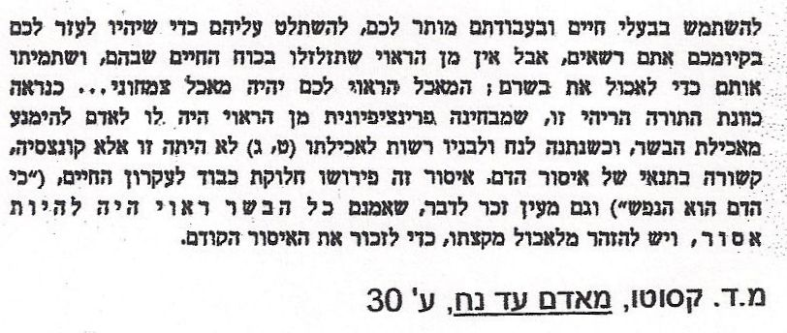

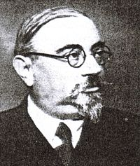You are permitted to use the animals and employ them for work, rule over them in order to utilize their services for your survival, but you must not hold their life cheap or kill them for food. Your natural diet is vegetarian… Apparently the Torah was in principle opposed to the eating of meat. When Noah and his descendants were permitted to eat meat this was a concession conditional on the law against eating blood. This law implied respect for the principle of life (“for the blood is the life”) and hints that in reality all meat should have been prohibited. This restriction was designed to call to mind the previous total one.

*Cassuto: From Adam to Noah, on Genesis 1:27*

**Umberto Cassuto** was also known as **Moshe David Cassuto** (1883–1951)

He was a rabbi and Biblical scholar born in Florence, Italy.

*Picture: https://en.wikipedia.org/wiki/Umberto_Cassuto*

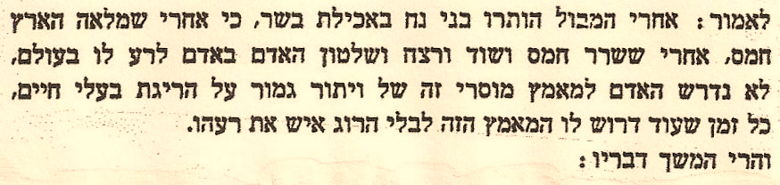

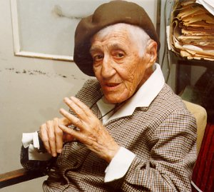

Since the land had become filled with violence and man had given free rein to his worst instincts, man was no longer required to go without the killing of animals for food. It was far more important that he should, at least, use what moral control he still had to hold back from killing his own kind and respecting the life of his neighbor.

*Nehama Leibowitz -1905-1997, was a famous Israeli Bible scholar who developed a particular style of Bible study that was very popular around the world. Nehama Leibowitz*

Picture; www.lookstein.org/nechama_biography.htm

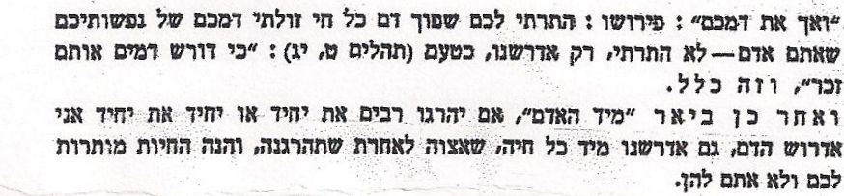

[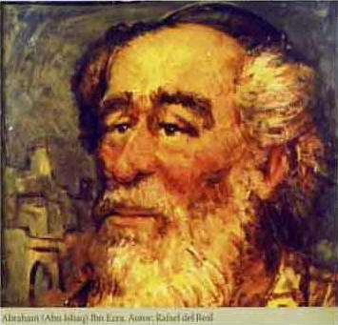](http://www.esefarad.com/?p=18101)

I permitted you to shed the blood of every living except your own blood which I did not permit since you are human. I shall require it …. This is a general rule. Subsequently the text explains its detailed application. "By the hand of man" – if many slay a single person or one individual another, I shall seek out the blood. I shall also seek it out from any beast, by commanding another to slay it. For animals are permitted to you but not you to them.  *Ibn Ezra.*

***Abraham Ibn Ezra.*** *Born in 1089 in Spain. He was a poet, astrologist, scientist, and an expert in Hebrew grammar. For more info. see* [*http://jewishcurrents.org/january-28-ibn-ezras-world-34990*](http://jewishcurrents.org/january-28-ibn-ezras-world-34990) *Picture: http://www.visitaporelmoncayo.com/*

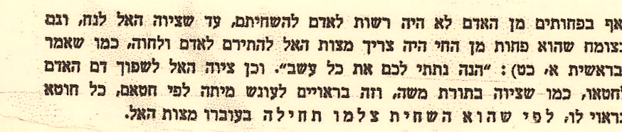

Permission was not given to man to destroy even the most inferior of his kind, until the Divine command to Noah. A special command of God was even required to allow Adam and Eve to make use of the plants which are lesser than the animals, as it is stated: (1:29): “behold I have given you all the herbs of the field.” *Similarly*, God commanded the shedding of a man’s blood, if his sin warranted it…. as in the Law of Moses, …. For man is the highest of God's creatures, created in His image and enjoying the gift of intelligence. Other creatures must therefore fear him and one man must not destroy the other, since by doing so man destroys the highest work of God, made in His image, and he goes and destroys it.

*Radak*

*“Radak” is short for” Rabbi David Kimchi” He was born in southern France in the year 1160. He came from a family of famous scholars, which gave rise the famous saying; Where there is no ‘kemach’ (flour) there is no bread”.*

[](http://blogs.forward.com/the-jew-and-the-carrot/)

*Previous*

October 7, 2010, 10:05am

# Parshat Noah: Pondering the Eating of Meat

#### By [Rachel Kahn-Troster](http://blogs.forward.com/authors/rachel-kahn-troster/)

In this week’s parsha, as Noah stands outside the ark surveying a post-deluge world, God blesses him and gives him new dietary parameters: “Every creature that lives shall be yours to eat; as with the green grasses, I give you all these.” (Genesis 9:3) This divine permission to eat meat is a big departure from the instructions given generations earlier to Adam and Eve, who were only allowed to eat a vegetarian diet.

No explanation is given in the torah for this change, which is bundled together with other injunctions against eating the blood of animals and against murder. But the rabbis argue that the permission to eat meat is an attempt to put boundaries on something people were doing prior to the flood, killing animals wantonly and without regard to the fact that to eat an animal was to take a life. God was setting up checks and balances to explicitly prevent this cruelty.

But “This concession to human weakness is not a license for savagery,” argues scholar Nahum Sarna. Meat cannot be eaten without recognition of its origins in life; God’s permission can be seen as the original injunction to eat mindfully.

…have we fulfilled our obligation to God by eating humanely raised meat, or should we be aiming for Edenic ideal of not eating meat at all?

Can eating meat ever be a holy act? I posed this dilemma to Naftali Hanau, owner of [Grow and Behold](http://www.growandbehold.com/), an ethical kosher meat company. Hanau, a former vegetarian (because of the historical lack of humanely raised kosher meat), argues that questions of sustainable eating must go beyond whether or not one should eat meat.

There are many overlooked trade-offs in the food system. “How is it any better to eat conventional tofu, made from genetically modified soy and grown on a field covered in petrochemical fertilizer? Conventional food does not get a free pass on environmental sustainability just because something is a vegetable.” He pointed out that Amish farmers who raise his chickens – moving the coops by hand and restoring the soil – leave a smaller environmental impact than conventional vegetable farming.

One question I posed to Hanau was whether having greater access to sustainable meat meant he ate more of it, as I have found to be true in my house. He said that it had not, but that it was still an ongoing conversation in his family about how much meat to eat. Purchasing sustainable meat is not a license to eat it mindlessly, he says.

All forms of eating can be savagery. All of them can be holy. This was the challenge to Noah and to us.

Rabbi Rachel Kahn-Troster is director of education and outreach for Rabbis for Human Rights-North America.

Read more: <http://blogs.forward.com/the-jew-and-the-carrot/131966/parshat-noah-pondering-the-eating-of-meat/#ixzz28PZaQiXf>

**New York Times Published May 3, 2012**

# Deciding what we should eat: secondary source HS

# The Ethicist Contest Winner: Give Thanks for Meat

###### http://graphics8.nytimes.com/images/2012/05/02/magazine/ethicist-winner-span/ethicist-winner-span-articleLarge.png **By JAY BOST:**

A few weeks ago, we[*invited readers to make an argument for the ethics of eating meat*](http://www.nytimes.com/2012/03/25/magazine/tell-us-why-its-ethical-to-eat-meat-a-contest.html). Thousands of readers submitted essays, and thousands more[*voted on the finalists that we posted online*](http://www.nytimes.com/interactive/2012/04/20/magazine/ethics-eating-meat.html). Our panel of judges — Mark Bittman, Jonathan Safran Foer, Andrew Light, Michael Pollan and Peter Singer — chose the essay below by Jay Bost as the winner.

As a vegetarian who returned to meat-eating, I find the question “Is meat-eating ethical?” one that is in my head and heart constantly. The reasons I became a vegetarian, then a vegan and then again a conscientious meat-eater were all ethical. The ethical reasons of why NOT to eat meat are obvious: animals are raised and killed in cruel conditions; grain that could feed hungry people is fed to animals; the need for pasture fuels deforestation; and by eating meat, one is implicated in the killing of a sentient [conscious] being. Except for the last reason, however, none of these aspects of eating meat are necessary, yet they are exactly what make eating some meat unethical. Which leads to my main argument: eating meat raised in specific circumstances is ethical; eating meat raised in other circumstances is unethical. Just as eating vegetables, tofu or grain raised in certain circumstances is ethical and those produced in other ways is unethical.

What are these “right” and “wrong” ways of producing both meat and plant foods? For me, they are summed up well in Aldo Leopold’s land ethic: “A thing is right when it tends to preserve the integrity, stability and beauty of the ecological community. It is wrong when it tends otherwise.”

While most present-day meat production is an ecologically foolish and ethically wrong endeavor, happily

this is changing, and there are abundant examples of ecologically beneficial, pasture-based systems. The fact is that most farmers interested in ecology agree that animals are integral parts of truly sustainable agricultural systems. They are able to cycle nutrients, aid in land management and convert sun to food in ways that are nearly impossible for us to do without fossil fuel. If “ethical” is defined as living in the most ecologically sound way, then in fairly specific circumstances, of which each eater must educate himself, eating meat is ethical; in fact NOT eating meat may be arguably unethical.

The issue of killing of a conscious being, however, lingers....

For me, eating meat is ethical when one does three things. First, you accept the biological reality that death is part of the chain of life on this planet … Second, you combine this realization with that cherished human trait of compassion and choose ethically raised food, vegetable, grain and/or meat. And third, you give thanks.

*[language slightly adapted]*

<http://www.nytimes.com/2012/05/06/magazine/the-ethicist-contest-winner-give-thanks-for-meat.html>



**Research the argument then hold a debate:**

**Should we eat meat?**

**(For clear presentations of many arguments from both sides go to)**

<http://debatewise.org/debates/938-should-humans-eat-meat/>

**Bereshit Chapter 9:8 -9:17- בְּרֵאשִׁית**

|  |  |
| --- | --- |
| **ח**  וַיֹּאמֶר אֱלֹהִים אֶל-נֹחַ, וְאֶל-בָּנָיו אִתּוֹ לֵאמֹר. | **8** And God said to Noah, and to his sons with him, saying: |
| **ט**  וַאֲנִי, הִנְנִי מֵקִים אֶת-בְּרִיתִי אִתְּכֶם, וְאֶת-זַרְעֲכֶם, אַחֲרֵיכֶם. | **9** 'As for Me, here, I now establish my covenant with you, and with your seed [children] after you; |
| **י**  וְאֵת כָּל-נֶפֶשׁ הַחַיָּה אֲשֶׁר אִתְּכֶם, בָּעוֹף בַּבְּהֵמָה וּבְכָל-חַיַּת הָאָרֶץ אִתְּכֶם; מִכֹּל יֹצְאֵי הַתֵּבָה, לְכֹל חַיַּת הָאָרֶץ. | **10** and with all living creatures that are with you, the fowl, herd-animals, and all the wildlife of the earth with you; with all those going out of the Ark, of all the living things on the earth. |
| **יא**  וַהֲקִמֹתִי אֶת-בְּרִיתִי אִתְּכֶם, וְלֹא-יִכָּרֵת כָּל-בָּשָׂר עוֹד מִמֵּי הַמַּבּוּל; וְלֹא-יִהְיֶה עוֹד מַבּוּל, לְשַׁחֵת הָאָרֶץ. | **11**  I will establish my covenant with you; never again shall all flesh be cut off again by waters of a flood; never again shall there be a flood, to destroy the earth! |
| **יב**  וַיֹּאמֶר אֱלֹהִים, זֹאת **אוֹת**-הַבְּרִית אֲשֶׁר-אֲנִי נֹתֵן בֵּינִי וּבֵינֵיכֶם, וּבֵין כָּל-נֶפֶשׁ חַיָּה, אֲשֶׁר אִתְּכֶם--לְדֹרֹת, עוֹלָם. | **12** And God said: 'This is the sign of the covenant which I set between me and you and all living creatures that are with you, for all ages to come: |
| **יג**  אֶת-קַשְׁתִּי, נָתַתִּי בֶּעָנָן; וְהָיְתָה לְ**אוֹת** בְּרִית, בֵּינִי וּבֵין הָאָרֶץ. | **13** My bow, I set in the cloud, so that it shall serve as a sign of the covenant between Me and the earth. |
| **יד**  וְהָיָה, בְּעַנְנִי עָנָן עַל-הָאָרֶץ, וְנִרְאֲתָה הַקֶּשֶׁת, בֶּעָנָן. | **14** And when I bring clouds over the earth, and the bow is seen, in the clouds |
| **טו**  וְ**זָכַר**ְתִּי אֶת-בְּרִיתִי, אֲשֶׁר בֵּינִי וּבֵינֵיכֶם, וּבֵין כָּל-נֶפֶשׁ חַיָּה, בְּכָל-בָּשָׂר; וְלֹא-יִהְיֶה עוֹד הַמַּיִם לְמַבּוּל, לְשַׁחֵת כָּל-בָּשָׂר. | **15** I will remember my covenant, which is between me and you and all living creatures of all flesh; so the waters shall no more become a flood to destroy all flesh. |
| **טז**  וְהָיְתָה הַקֶּשֶׁת, בֶּעָנָן; וּרְאִיתִיהָ, לִזְכֹּר בְּרִית עוֹלָם, בֵּין אֱלֹהִים, וּבֵין כָּל-נֶפֶשׁ חַיָּה בְּכָל-בָּשָׂר אֲשֶׁר עַל-הָאָרֶץ. | **16** When the bow will be, in the cloud; I will see it, and remember the covenant between God and all living creatures - all flesh that is on the earth |
| **יז**  וַיֹּאמֶר אֱלֹהִים, אֶל-נֹחַ:  זֹאת אוֹת-הַבְּרִית, אֲשֶׁר הֲקִמֹתִי, בֵּינִי, וּבֵין כָּל-בָּשָׂר אֲשֶׁר עַל-הָאָרֶץ.  {פ} | **17** And God said to Noah: 'This is the sign of the covenant which I have established between me and all flesh that is upon the earth.' |
| **יח**  וַיִּהְיוּ בְנֵי-נֹחַ, הַיֹּצְאִים מִן-הַתֵּבָה--שֵׁם, וְחָם וָיָפֶת; וְחָם, הוּא אֲבִי כְנָעַן. | **18** And the sons of Noah, that went out from the Ark, were Shem, and Ham, and Japheth; and Ham is the father of Canaan. |

**Leading Idea: Establishing and Maintaining**

**Establishing (**מֵקִים **), remembering (**לִזְכֹּר**) and remembering in the future** (**זָכַר**ְתִּי)

In Verses 9:8-17 God turns his attention from Noah to himself. “As for me…” Within this passage he reflects on the act of *establishing* a covenant and remembering it – that is *maintaining* a covenant (keeping it over time), and the intention to keep it in the future (I will remember). God also reflects on the ‘sign’ (אות) , or rainbow, as *representing* the covenant (as a sign of the covenant), as a way of *showing us* of his intentions (it stands as a sign between me and you), and as a way of *reminding himself* of his covenant. These exercises and discussion plans explore these subtle yet very powerful distinctions.

**Discussion Plan: Establishing something and Maintaining it**

*Is there a difference between these things, if so, what is the difference?*

* Setting a rule that says "do not enter the room without knocking"
* Remembering to keep the rule that says "do not enter the room without knocking"
* Starting a friendship
* Keeping that person as a friend
* Earning a name for being fair
* Remembering to always be fair
* Keeping a name for being fair once you have it

*What is the difference between…*

* Putting a sign on the door to *show* visitors that they can't enter without knocking.
* Putting a sign on the door to *remind* visitors that they can't enter without knocking.
* Putting a sign on the door to *remind yourself* that you shouldn’t let visitors in unless they have knocked on the door first.

**When might you need to post each of these signs?**

**Inter-textual exploration - The meaning of אות**

Using a Tanach, Look up the following references. Is there any difference between the meaning of  ( אות ) in these passages? What do you think the function of the ( אות ) is in each case?  (to show? tell? remind? something else?)

* Bereshit 4:15 (Cain and Abel)
* Shemot 31:13 (Shabbat)
* Shemot 31: 17 (Shabbat)
* Shemot 8:18-19 (Plagues)
* Shemot 12:13 (Blood on the doorposts)

**Activity: Handmade Midrash: ‘This is the sign of the covenant’**

|  |  |
| --- | --- |
| **יב**  וַיֹּאמֶר אֱלֹהִים, זֹאת **אוֹת**-הַבְּרִית אֲשֶׁר-אֲנִי נֹתֵן בֵּינִי וּבֵינֵיכֶם, וּבֵין כָּל-נֶפֶשׁ חַיָּה, אֲשֶׁר אִתְּכֶם--לְדֹרֹת, עוֹלָם. | **12** And God said: 'This is the sign of the covenant which I set between me and you and all living creatures that are with you, for all ages to come: |
| **יג**  אֶת-קַשְׁתִּי, נָתַתִּי בֶּעָנָן; וְהָיְתָה לְ**אוֹת** בְּרִית, בֵּינִי וּבֵין הָאָרֶץ. | **13** My bow, I set in the cloud, so that it shall serve as a sign of the covenant between Me and the earth. |

Make a ‘Handmade Midrash’ that draws on how you understand this textin light of the distinctions you explored in your community of inquiry. Make your midrash from colored construction paper by tearing forms out of the paper and sticking them onto a background sheet of paper.

**Handmade Midrash** is a process of interpretation developed by **Jo Milgrom**. Her process has a number of stages:

1. Text Study
2. Creation of an artwork
3. Discussion in small groups
4. Reflective writing on what you can learn through looking at what you created more carefully.
5. Return to the text

* The artwork is created through tearing paper and attaching it to a background. It is not about creating a realistic kind of picture, but capturing ideas and representing them – often through symbolic representation –the torn paper represents ideas in relation to one another. It doesn’t require you to be ‘good at art’ as you can represent ideas through abstract shapes, a blob, color, etc.
* After you have created your midrash, divide into small groups to share what you have done and what it means. Here what other people see in what your midrash. Describe what was the hardest and easiest elements to do, what role color plays in your midrash, why you placed things where you did, how the parts relate to one another, etc.
* After the discussion, take some time to do some reflective writing. You might like to think about some of the following prompts: Did anything surprise you in what you constructed? In what people saw in it? How did the ideas come together? How does what is happening in the picture relate to your own feelings and thoughts about the world you live in? How does it relate to your own feelings and thoughts about the Divine human connection?

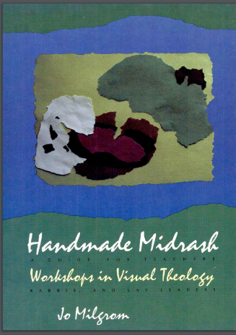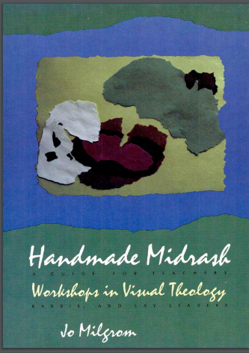

**Leading Idea: Caring for our world**

This section of text about the Keshet comes after the flood – after God in his anger almost completely destroys the world. The Keshet is a reminder to God to avoid global destruction in the future. This raises a larger question about our relationship to the world and our care for it. The following poem can invite discussion around our sensory experiencing of the world and our care for it. You might like to create your own poem that draws on the way your students’ own experiences of connecting to the world through their senses.

**Deuteronomy 20:18-19**

|  |  |  |
| --- | --- | --- |
| **1**[**9**](http://www.chabad.org/library/bible_cdo/aid/9984#v=19) When you besiege a city for many days to wage war against it to capture it, you shall not destroy its trees by wielding an ax against them, for you may eat from them, but you shall not cut them down. Is the tree of the field a man, to go into the siege before you? |  | **יט** כִּי תָצוּר אֶל עִיר יָמִים רַבִּים לְהִלָּחֵם עָלֶיהָ לְתָפְשָׂהּ לֹא תַשְׁחִית אֶת עֵצָהּ לִנְדֹּחַ עָלָיו גַּרְזֶן כִּי מִמֶּנּוּ תֹאכֵל וְאֹתוֹ לֹא תִכְרֹת כִּי הָאָדָם עֵץ הַשָּׂדֶה לָבֹא מִפָּנֶיךָ בַּמָּצוֹר: |
| **[20](http://www.chabad.org/library/bible_cdo/aid/9984" \l "v=20)** However, a tree you know is not a food tree, you may destroy and cut down, and you shall build bulwarks against the city that makes war with you, until its submission. |  | **כ** רַק עֵץ אֲשֶׁר תֵּדַע כִּי לֹא עֵץ מַאֲכָל הוּא אֹתוֹ תַשְׁחִית וְכָרָתָּ וּבָנִיתָ מָצוֹר עַל הָעִיר אֲשֶׁר הִוא עֹשָׂה עִמְּךָ מִלְחָמָה עַד רִדְתָּהּ: |

**D'Var Torah**

Harriet M. Levine, Woodlands Community Temple, White Plains, NY

[*http://www.reformjudaism.org/learning/torah-study/shoftim/protect-trees-protect-our-world*](http://www.reformjudaism.org/learning/torah-study/shoftim/protect-trees-protect-our-world)

... These verses toward the end of the *parashah*, Deuteronomy 20:19-20, form the basis for the mitzvah*bal tashchit*, "do not destroy." While the verses themselves deal specifically with cutting down trees during war, the Sages extended their meaning to cover all forms of wasteful destruction. They taught that anyone who deliberately wastes our resources, either natural or man-made, violates the law.

For over 3,000 years Jews have been concerned about the environment. Although these instructions are specifically directed to the care of fruit trees during war, the lesson gleaned from them has far-reaching implications for life on this planet. Our ancestors understood that life depends upon preserving the land. Although they didn't use words like "ecology," "global warming," or "environmental crisis," they clearly understood and respected these concepts.

The tree in the Torah text is read by the Sages as a metaphor. They understood that the prohibition to destroy fruit trees implies that it is forbidden to destroy anything that was beneficial to humankind. Maimonides' *Mishneh Torah* tells us that a tree may be cut down if it damages other trees or causes harm to neighboring fields. According to Maimonides, the Torah only forbids willful destruction. We are not precluded from making use of God's creations but are warned against unnecessarily destroying gifts of nature. Needless cutting down of a fruit-bearing tree is forbidden not only in wartime, but at all times. Similarly, we may not destroy or waste anything useful, whether it be food or money or clothing.

In the creation story in Genesis 1:28, humankind is granted dominion over the earth. The same biblical passage that gives us this dominion also requires that we care for the earth; we are reminded that even as we till the earth, we must also preserve it. God's command to "rule the fish of the sea, the birds of the sky, and all the living things that creep on earth" gives us the responsibility to guard the world. Because God created the natural world, it is sacred. It is ours on loan, to be used and cared for. We are granted both dominion and stewardship of our world; therefore we are not to pollute its water or air or waste its precious resources.

As a child in religious school, one of the first stories I heard was that of Honi and his planting of the carob tree. When asked why he was planting a tree that would not bear fruit until long after his death, he replied that when he came into the world he found carob trees that had been planted by those who came before him, so he was doing the same for his descendants. It's a simple story that we tell every Tu BiSh'vat, but one that teaches an age-old truth.

Today's environmentalists raise the same concern as Honi. Since the mid-twentieth century, we have become aware that restoring our planet's diminishing resources is a crucial issue. The destruction of tropical forests, lumbering without reforestation, burning of land, and the general wasting of other natural resources will leave future generations with diminished resources. Just over forty years ago, author Rachel Carson warned of the dangerous effects of our lifestyle on the environment. *Silent Spring* spoke of our reckless attempt to control our environment by the use of pesticides and warned that destroying the balance of nature would ultimately do more harm than good.

Since Carson's best-selling publication, others have written on the same subject. Just ten years ago, Al Gore, in his book *Earth In the Balance,* wrote of his conviction that only radical rethinking of our relationship with nature could save our ecology. Whether or not we believe that we must save our resources because God has commanded us to do so, we cannot ignore what we have done to our world or sit idle without trying to correct the mistakes we've made.

Judaism does not separate people from nature. We're taught that the earth is one unit, just as God is one. Whatever affects plant and animal life affects humans as well. If we destroy other kinds of living things on this earth, we are also destroying ourselves. The most important lessons we can teach our children are that not only do all living things depend upon each other, but also what we do today affects what the world will be like tomorrow. Each generation is linked to the next by its actions. Like Honi, we depend on what those who came before us did, as our children will depend upon us. Whether it is wartime or peacetime, we must care for the natural resources entrusted to us.

**By the way....**

***Look upon This Land*** *Look upon this land—  
Touch it.  
Sand under your bare feet,  
The squish of mud,  
Silky coat of cat,  
Soft rose petals,  
A smooth round rock,  
Rain on your face.  
  
Touch it with your eyes.  
Cherry trees blossoming pink,  
Lake of blue and summer sky,  
The green of life,  
Purple grapes and apples red,  
Moon rising yellow,  
Orange sun going down.  
  
Touch it with your ears.  
Splatter of rain,  
Crack of thunder,  
Wind whispering,  
Birds singing,  
The crying of babies and puppies,  
Kittens and ducklings.  
  
Touch it with your nose.*

*Pine-scent of woods, lilacs blooming,*

*new-mown grass, smoke of chimneys,*

*strawberries in the sun.*

*Touch it with your tongue.  
Lick of sugar,  
Tang of lemon, ginger, or spice,  
Bite of cold snow,  
Gulp of pure water.  
  
Look upon this land—  
Touch it.  
Touch it in every way you can,  
For this land is part of you,  
And you are part of it.*

*Given into your care is this earth.  
See how beautiful it is.  
Be careful not to spoil it,  
For if you destroy the world,  
There will be no one after you to restore it.  
(Kohelet Rabbah 1 on Ecclesiastes 7:13)*

*(Molly Cone, Listen to the Trees [New York: UAHC Press, 1995], pp. 42-43)*

Throughout the Bible, we are urged to respect creation and not waste or destroy. Living things range from the human being to the simplest of species, and the rich variety of nature is to be cherished. In addition, Jewish tradition is distinctly linked to trees and to water; in fact, our Torah is referred to as the "Tree of Life." Jewish tracts entreat us time and again to respect and enhance trees and water.

**Your Guide**

* Torah has a multitude of verses regarding the care of our resources. How do we decide which ones to follow? Do we pick and choose only those that affect us personally, or do we move beyond our own neighborhoods, cities, and even countries for the betterment of all humankind?
* How, in this age of technology, can we ensure that we don't do more damage to our natural resources-our drinking water, our rivers, the soil, or the air?
* When our military goes into another country to liberate it, as we have recently done in Iraq, do we have any obligations to the people of that country regarding the protection of their natural resources?

**Activity**

As a class, or in small groups, create a class poem or artwork that draws on the way you experience your connection to the world through your senses.

