# Parshat Tazria-Metzora -  פרשת תזריע־מצרע

**April 28, 2012**

***(Together with other passages on Leprosy)***

# Vayikra 13:1-6 ויקרא

|  |  |  |
| --- | --- | --- |
| **1.**And the Lord spoke to Moses and Aaron, saying: |  | **א.**וַיְדַבֵּר יְ־הֹוָ־ה אֶל מֹשֶׁה וְאֶל אַהֲרֹן לֵאמֹר: |
| **2.**If a man has one of several different kinds of scaly blemishes or sores on the skin of his flesh, and it forms a skin patch of tzara'at [leprosy] on the skin of his flesh, he shall be brought to Aaron the kohen, or to one of his sons, the kohanim. |  | **ב.**אָדָם כִּי יִהְיֶה בְעוֹר בְּשָׂרוֹ שְׂאֵת אוֹ סַפַּחַת אוֹ בַהֶרֶת וְהָיָה בְעוֹר בְּשָׂרוֹ לְנֶגַע צָרָעַת וְהוּבָא אֶל אַהֲרֹן הַכֹּהֵן אוֹ אֶל אַחַד מִבָּנָיו הַכֹּהֲנִים: |
| **3.**The kohen shall look at the change on the skin of his flesh, and [if] hair in the patch has turned white and the appearance of the patch is deeper than the skin of his flesh, it is a patch of tzara'at. When the kohen sees this, he shall pronounce him unclean. |  | **ג.**וְרָאָה הַכֹּהֵן אֶת הַנֶּגַע בְּעוֹר הַבָּשָׂר וְשֵׂעָר בַּנֶּגַע הָפַךְ לָבָן וּמַרְאֵה הַנֶּגַע עָמֹק מֵעוֹר בְּשָׂרוֹ נֶגַע צָרַעַת הוּא וְרָאָהוּ הַכֹּהֵן וְטִמֵּא אֹתוֹ: |
| **4. But if it is a white blemish or sore on the skin of his flesh, and its appearance is not deeper than the skin, and its hair has not turned white, the kohen shall quarantine the [person with the] lesion for seven days.** |  | **ד.**וְאִם בַּהֶרֶת לְבָנָה הִוא בְּעוֹר בְּשָׂרוֹ וְעָמֹק אֵין מַרְאֶהָ מִן הָעוֹר וּשְׂעָרָה לֹא הָפַךְ לָבָן וְהִסְגִּיר הַכֹּהֵן אֶת הַנֶּגַע שִׁבְעַת יָמִים: |
| **5.**And on the seventh day, the kohen shall see him. And, behold! the skin change has remained the same in its appearance; the patch has not spread on the skin. So the kohen shall quarantine him for seven days a second time. |  | **ה.**וְרָאָהוּ הַכֹּהֵן בַּיּוֹם הַשְּׁבִיעִי וְהִנֵּה הַנֶּגַע עָמַד בְּעֵינָיו לֹא פָשָׂה הַנֶּגַע בָּעוֹר וְהִסְגִּירוֹ הַכֹּהֵן שִׁבְעַת יָמִים שֵׁנִית: |
| **6.**And the kohen shall see him on the seventh day a second time. And, behold! the skin change has become dimmer, and the patch has not spread on the skin, the kohen shall pronounce him clean. It is not a ‘bad’ sore. He shall immerse his garments and become clean. |  | **ו.**וְרָאָה הַכֹּהֵן אֹתוֹ בַּיּוֹם הַשְּׁבִיעִי שֵׁנִית וְהִנֵּה כֵּהָה הַנֶּגַע וְלֹא פָשָׂה הַנֶּגַע בָּעוֹר וְטִהֲרוֹ הַכֹּהֵן מִסְפַּחַת הִיא וְכִבֶּס בְּגָדָיו וְטָהֵר: |

|  |  |  |  |
| --- | --- | --- | --- |
| **במִדְבַּר**. **Bamidbar 12:1-15** | | | |
| **א**  וַתְּדַבֵּר מִרְיָם וְאַהֲרֹן בְּמֹשֶׁה, עַל-אֹדוֹת הָאִשָּׁה הַכֻּשִׁית אֲשֶׁר לָקָח:  כִּי-אִשָּׁה כֻשִׁית, לָקָח. | | **1 And Miriam and Aaron spoke against Moses because of the Cushite woman whom he had married; for he had married a Cushite woman.** | | | |
| **ב**  וַיֹּאמְרוּ, הֲרַק אַךְ-בְּמֹשֶׁה דִּבֶּר יְהוָה--הֲלֹא, גַּם-בָּנוּ דִבֵּר; וַיִּשְׁמַע, יְהוָה. | | **2 And they said: 'Hath the LORD indeed spoken only with Moses? Has He not spoken also with us?' And the LORD heard it.--** | | | |
| **ג**  וְהָאִישׁ מֹשֶׁה, עָנָו מְאֹד--מִכֹּל, הָאָדָם, אֲשֶׁר, עַל-פְּנֵי הָאֲדָמָה. | | **3** Now the man Moses was very meek, above all the men that were upon the face of the earth | | | |
| **ד**  וַיֹּאמֶר יְהוָה פִּתְאֹם, אֶל-מֹשֶׁה וְאֶל-אַהֲרֹן וְאֶל-מִרְיָם, צְאוּ שְׁלָשְׁתְּכֶם, אֶל-אֹהֶל מוֹעֵד; וַיֵּצְאוּ, שְׁלָשְׁתָּם. | | **4 And the LORD spoke suddenly to Moses, and to Aaron, and to Miriam: 'Come out , the three of you, to the tent of meeting.' And the three of them came out.** | | | |
| **ה**  וַיֵּרֶד יְהוָה בְּעַמּוּד עָנָן, וַיַּעֲמֹד פֶּתַח הָאֹהֶל; וַיִּקְרָא אַהֲרֹן וּמִרְיָם, וַיֵּצְאוּ שְׁנֵיהֶם. | | **5 And the LORD came down in a pillar of cloud, and stood at the door of the Tent, and called Aaron and Miriam; and they both came forth.** | | | |
| **ו**  וַיֹּאמֶר, שִׁמְעוּ-נָא דְבָרָי; אִם-יִהְיֶה, נְבִיאֲכֶם--יְהוָה בַּמַּרְאָה אֵלָיו אֶתְוַדָּע, בַּחֲלוֹם אֲדַבֶּר-בּוֹ. | | **6** And He said: 'Hear now My words: if there is a prophet among you, I the LORD make Myself known to him in a vision, I speak with him in a dream. | | | |
| **ז**  לֹא-כֵן, עַבְדִּי מֹשֶׁה:  בְּכָל-בֵּיתִי, נֶאֱמָן הוּא. | | **7** My servant Moses is not like this; he is trusted in all My house; | | | |
| **ח**  פֶּה אֶל-פֶּה אֲדַבֶּר-בּוֹ, וּמַרְאֶה וְלֹא בְחִידֹת, וּתְמֻנַת יְהוָה, יַבִּיט; וּמַדּוּעַ לֹא יְרֵאתֶם, לְדַבֵּר בְּעַבְדִּי בְמֹשֶׁה. | | **8** with him I speak mouth to mouth, even in a way that is perceived by the senses , and not in dark speeches [riddles]; and the image [likeness] of the LORD he sees; so why are you not afraid to speak against My servant, against Moses?' | | | |
| **ט**  וַיִּחַר-אַף יְהוָה בָּם, וַיֵּלַךְ. | | **9** And the anger of the LORD was kindled against them; and He departed. | | | |
| **י**  וְהֶעָנָן, סָר מֵעַל הָאֹהֶל, וְהִנֵּה מִרְיָם, מְצֹרַעַת כַּשָּׁלֶג; וַיִּפֶן אַהֲרֹן אֶל-מִרְיָם, וְהִנֵּה מְצֹרָעַת. | | **10** **And when the cloud was removed from over the Tent, behold, Miriam she was with tzara’at [she was leprous], as white as snow; and Aaron looked upon Miriam; and, behold, she had Tzara’at [she was leprous].** | | | |
| **יא**  וַיֹּאמֶר אַהֲרֹן, אֶל-מֹשֶׁה:  בִּי אֲדֹנִי--אַל-נָא תָשֵׁת עָלֵינוּ חַטָּאת, אֲשֶׁר נוֹאַלְנוּ וַאֲשֶׁר חָטָאנוּ. | | **11** And Aaron said to Moses: 'Oh my lord, do not – please - place sin upon us because we have acted foolishly, and in doing so, have sinned. | | | |
| **יב**  אַל-נָא תְהִי, כַּמֵּת, אֲשֶׁר בְּצֵאתוֹ מֵרֶחֶם אִמּוֹ, וַיֵּאָכֵל חֲצִי בְשָׂרוֹ. | | **12** Let her not, I pray, be as one dead, of whom the flesh is half consumed when he comes out of his mother's womb.' | | | |
| **יג**  וַיִּצְעַק מֹשֶׁה, אֶל-יְהוָה לֵאמֹר:  אֵל, נָא רְפָא נָא לָהּ. | | **13 And Moses cried to the LORD, saying: 'Heal her now, O God, I beseech You.'** | | | |
| **יד**  וַיֹּאמֶר יְהוָה אֶל-מֹשֶׁה, וְאָבִיהָ יָרֹק יָרַק בְּפָנֶיהָ--הֲלֹא תִכָּלֵם, שִׁבְעַת יָמִים; תִּסָּגֵר שִׁבְעַת יָמִים, מִחוּץ לַמַּחֲנֶה, וְאַחַר, תֵּאָסֵף. | | **14 And the LORD said to Moses: 'If her father had spat in her face, should she not hide in shame seven days? let her be isolated [shut up]outside the camp seven days, and after that she shall be brought in again.'** | | | |
| **טו**  וַתִּסָּגֵר מִרְיָם מִחוּץ לַמַּחֲנֶה, שִׁבְעַת יָמִים; וְהָעָם לֹא נָסַע, עַד-הֵאָסֵף מִרְיָם. | | **15** **And Miriam was isolated [shut up] outside the camp seven days; and the people did not continue their journeyed until Miriam was brought in again.** | | | |
| **Deuteronomy 25:7-9 דְּבָרִים** | | | | | |
| **7.**If a man is discovered kidnapping any person from among his brothers, of the children of Israel, and treats him as a slave and sells him, that thief shall die so that you shall clear out the evil from among you. | | |  | **ז.**כִּי יִמָּצֵא אִישׁ גֹּנֵב נֶפֶשׁ מֵאֶחָיו מִבְּנֵי יִשְׂרָאֵל וְהִתְעַמֶּר בּוֹ וּמְכָרוֹ וּמֵת הַגַּנָּב הַהוּא וּבִעַרְתָּ הָרָע מִקִּרְבֶּךָ: |
| **8. Be cautious regarding the lesion of tzara'ath, to observe - carefully and exactly – all that the Levite priests instruct you to do; as I have commanded them, [so shall you] observe to do.** | | |  | **ח.**הִשָּׁמֶר בְּנֶגַע הַצָּרַעַת לִשְׁמֹר מְאֹד וְלַעֲשׂוֹת כְּכֹל אֲשֶׁר יוֹרוּ אֶתְכֶם הַכֹּהֲנִים הַלְוִיִּם כַּאֲשֶׁר צִוִּיתִם תִּשְׁמְרוּ לַעֲשׂוֹת: |
| **9. Remember what the Lord, your God, did to Miriam on the way, when you went out of Egypt.** | | |  | **ט.**זָכוֹר אֵת אֲשֶׁר עָשָׂה יְ־הֹוָ־ה אֱלֹהֶיךָ לְמִרְיָם בַּדֶּרֶךְ בְּצֵאתְכֶם מִמִּצְרָיִם: |
| **10.**When you lend your fellow [Jew] any item, you shall not enter his home to take his security. | | |  | **י.**כִּי תַשֶּׁה בְרֵעֲךָ מַשַּׁאת מְאוּמָה לֹא תָבֹא אֶל בֵּיתוֹ לַעֲבֹט עֲבֹטוֹ: |
| **11.**You shall stand outside, and the man to whom you are extending the loan shall bring the security to you outside. | | |  | **יא.**בַּחוּץ תַּעֲמֹד וְהָאִישׁ אֲשֶׁר אַתָּה נֹשֶׁה בוֹ יוֹצִיא אֵלֶיךָ אֶת הַעֲבוֹט הַחוּצָה: |

**______________________________________________________________________________**

**Different kinds of skin blemishes, scaly skin, or sores**

se'eith, שְׂאֵת

sappachath, סַפַּחַת

bahereth בַהֶרֶת

Tzara’at צָרָעַת

**Leading Idea: Tzara’at and its implications**

**Leading Idea: Teaching Challenging Texts**

Parshat Tazria-Metzora is a challenging text, and as such, offers us a number of teaching opportunities.

(i) **the opportunity to deal with what is usually considered a ‘difficult text’** – its difficulty lies in:

* the distance the subject seems to have from contemporary life,
* in the fact that it is not exactly clear which disease or sets of diseased these terms refer to

( se’eth שְׂאֵת, sappachath סַפַּחַת, bahereth בַהֶרֶת and Tzara’at צָרָעַת - for further information see: <http://www.jewishvirtuallibrary.org/jsource/judaica/ejud_0002_0012_0_12153.html>) and

* to its technical dryness of delivery
* and added to this, is its association with Miriam’s punishment of Tzara’at.

(ii) **the opportunity to model a different way in which Jewish tradition interprets Biblical text.** This is to see the Torah as if all was simultaneously present – where the meaning of one passage gains its meanings through other passages in which the same issue is dealt with or the same events mentioned. The section on Tzara’at in this parashah is often interpreted in light of Miriam’s Tzara’at as ‘punishment’ for Lashon hara (Bamidbar 12:1-15). Reading Vayikra with this text in mind we might ask why it is the *Kohen* who examines scally conditions of the skin (why is the spiritual leader rather than someone with medical knowledge?) and why recovery from such a state requires ritual offering (including the intriguing requirement of bringing two birds as offerings – one to be slaughtered and one to be set free). Linking tzara’at with the ‘moral disease’ of lashon hara – speaking evil of others, or gossiping – is one way of responding to these questions. This is reinforced by the third text from Devarim, which links what happened to Miriam back to the role of the Levites in parshat Tazria-Metzora

**For Primary school:**

Reading all three texts with your students is a lot of reading - as a strategy, you might want to read the first text from Vayikra around the circle, then pause to take a few questions, then have the teacher read the next two texts (from Bamidbar and Devarim), or tell the story from Bamidbar in their own words and then read the third, and then raise more questions as a group.

(iii) **Another opportunity presented by this text – or perhaps a challenge – concerns teaching this text in its context.** In order that this parashah has meaning for the reader, we need to check that our students understand many of the terms that are mentioned, and of the relationships  between the different  characters. This will require stopping during the reading and checking that students have the context in which to understand what is going on. This is especially the case when all three texts are used together.  For example, the passage in Bamidbar, dealing with Aaron and Miriam’s action,  may require *narrative context* to be given (where and when is this taking place? What is the tent of meeting?). In the case of  the short text from Devarim insight can be gained by looking at its immediate *textual context*  which deals with moral behaviors (reinforcing the connection between of tzara’at  and moral/spiritual issues).

**Despite the difficulty of these texts, the themes are ones that students in primary school and high school can relate to – themes of social responsibility toward infectious diseases; the problematic nature of gossip/lashon hara, the issue of handing out punishment , and the connection between outer physical conditions and inner states. The discussion plans and exercises explore some of these issues through examples that allow the student to explore them in the context of their own world. The range of Jewish texts further explore the link between outer and inner health and the damage that lashon hara does.**



**Leading Idea:  Tzara’at and its implications**

Some helpful conceptual distinctions  raised by the exercises  and secondary sources that are worth keeping in mind when exploring this theme are:

Isolation

* to protect others from you (contagious diseases),
* to protect you from  them (Leukemia, where you might fall sick from being in touch with others),
* to enable you to get better (spending time 'away' in a psychiatric hospital where you can then get the care and help you need).

This can lead nicely into the text  on lashon  hara as a spiritual disease,  and to also to think about the kind of isolation  Miriam 's isolation was.

**Pu**nishment

* Punishment other people inflict on you
* Punishment that you inflict on yourself through self- neglect (not looking after yourself)
* Punishment you inflict upon yourself  as a result of a psychological condition (feeling guilty, anorexia, depression).
* Punishment that is deserved v's  punishment that is undeserved
* Punishment that 'matches' the crime (is relevant to what was done)  v's punishment that is simply meant to inflict suffering.

**What physical symptoms could be the result of punishment?**

**Who is doing the punishing?**

Pinocchio’s nose growing longer

Rashes

Pimples

Flu

Bruises

Chicken pox

Broken leg

Tummy ache

Sunburn

**How do we decide if something we experience is a punishment?**

1. Your parents ground you
2. Your parents ask you to look after your baby brother/sister
3. You receive homework from your teacher
4. Your mother says you can’t go out until you clean your room
5. You are teased at school
6. You get sick just as the holidays start and can’t spend time with our friends
7. You forgot our friend’s birthday and the next day you find out that they forgot to invite you to their party.

**Look up these examples of Lashon hara – what were the consequences?**

1. **Bereshit 3: 1-20** The serpant uses ‘lashon hara’ with Eve
2. **Bereshit 37:2**  Joseph uses ‘lashon hara’ with his brothers

**Commentary**

**By Rabbi Jonathan Cohen**

**(Rabbi of Michkan Torah, Greenbelt, MD)**

**Mishkan Torah is a member of both the Reconstructionist and Conservative movements**

Adapted from: <http://www.mishkantorah.org/rabbi-jonathan-cohen/tazria-metzora>

The sages taught that *tzara'at* was not a physical disease, but a spiritual one. They believed that it was a punishment for saying bad or untrue things about others. They said that the Hebrew wordfor the person afflicted with *tzara'at*  means "one who spreads slander." The "treatment" or punishment for this was being placed in ‘time out’. During this time of isolation, the person had time to reflect on the damage done by his or her words.

Once the condition had been cured, the person then offered a sacrifice including two birds: one to slaughter and one to set free.

**Q: Why do you think one bird was slaughtered and one set free?**

According to the *Mishnah* (*Nega'im* 2:2) people who see white, leprous-like spots on their skin should not inspect themselves to determine whether they have a case of *tzara'at*. Rather, they should have a *kohain* perform the inspection for them. This is because most of us are quite incapable of seeing our own blemishes (spots, faults).

**Midrash *Shocher Tov*:**

"The damage done by evil talk is compared to the piercing destruction of an arrow. Why is the tongue compared to an arrow? An arrow cannot be called back once it has been shot, even if the marksman wishes to do so. Just as the victim does not know about it until it actually reaches him, so the effects of evil talk are not felt until the arrows of a wicked person pierce him."

**The Story of Kamza and Bar Kamza**

**Yom Kippur 5772 October 7/8, 2011**

**Rabbi Ronne Friedman, Temple Israel, Boston**

A Talmudic story that purports to explain the reason that the Temple was destroyed tells us of a certain unidentified man who “had a friend named Kamza and an enemy by the name of Bar Kamza. This man threw a party and said to his servant, go and bring Kamza back to the party. The servant, however, went and brought Bar Kamza.

When the host found Bar Kamza there at his party, he said, “Look, you gossip about me; what are you doing here? Get out.” Bar Kamza replied: “Since I am here, let me stay, and I will pay you for whatever I eat and drink.”The host said, “I won't.” Bar Kamza then said, “Let me give you half the cost of the party.” “No,” said the host. “Then let me pay for the whole party.” The host still refused, and he took Bar Kamza by the arm and put him out.

Bar Kamza said to himself, “Since the Rabbis were sitting there and did not stop him, this shows that they agreed with him. I will go and inform against them, to the Government. He went and said to the Emperor of Rome, the Jews are rebelling against you….”

-----------------------------

1 Note from this incident, the Talmud concludes, how serious a thing it is to put a person to shame, for God espoused the cause of Bar Kamza and as a result God destroyed His own House and burnt His own Temple (and we ourselves have been exiled from the land.)

2 The rabbis seize upon this most painful historical event in their experience, the destruction of the Temple, and identify it as a divine consequence of the humiliation of an enemy.



**Words Matter**

##### Rabbi Irwin Katsof, the Founder of [Words Can Heal](http://www.wordscanheal.org/) believes that words can make a difference - and that if we only paid more attention to the way we speak, we could stop a lot of pain and suffering in the world.

##### **If you agree with Rabbi Katsof, develop your own system of road signs and put them up around the school.**

[](http://209.41.176.203/~parshat/wp-content/uploads/2012/04/zero_limit.jpg)



**What Damage does Lashon Hara do? Discussion and Activity**

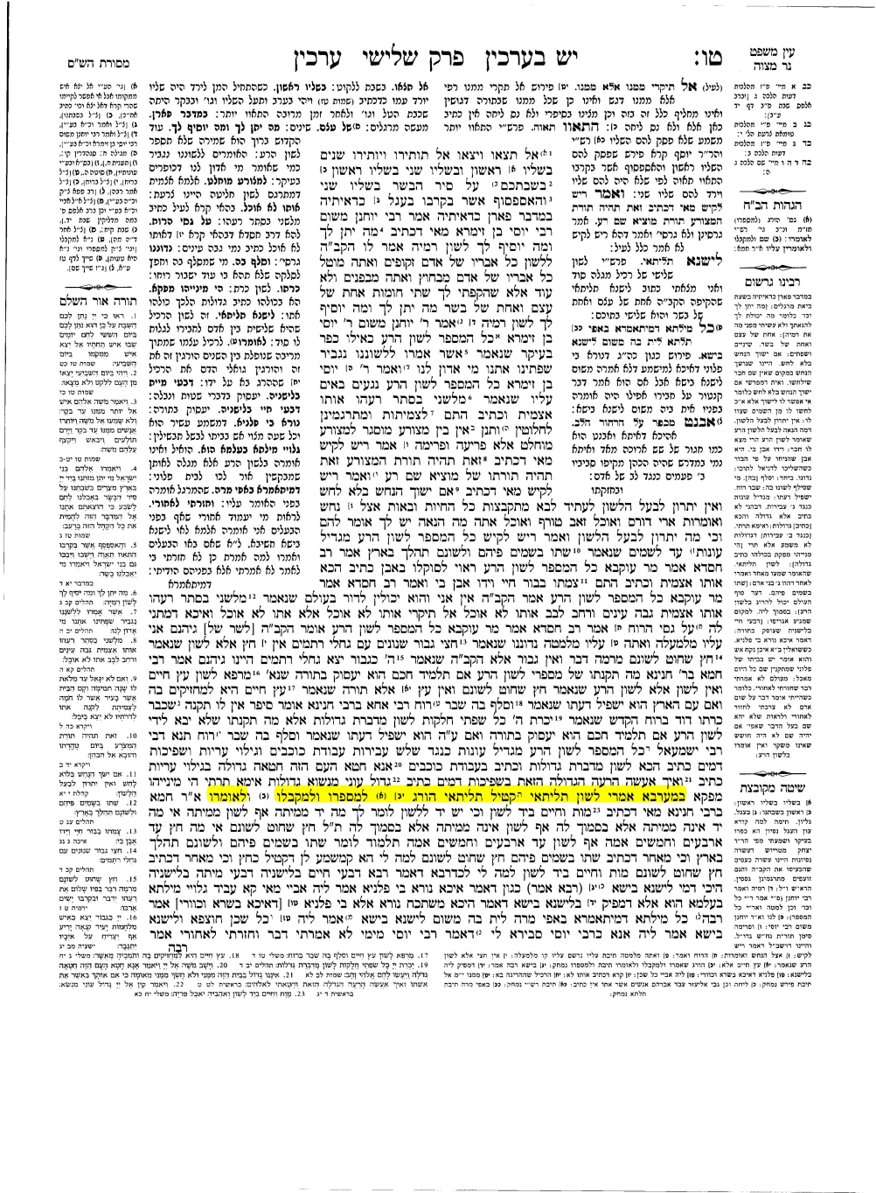



**It said in the name of "The School of Rabbi Ishmael".**

Lashon hara destroys 3 people: He who tells Lashan hara. He who listens to it, and the one about whom it is told" (Arahin 15b)

*Discuss: Do you think this true? If so in what ways? Can you offer examples?*

**Arachim 15b - Do one of the following:**

* Make a poster about Lashon hara for the school
* Draw your own interpretation of this passage from the Talmud
* Create a skit that demonstrates the message of this passage