**Vayeira: Bereshit 18:9-15  בְּרֵאשִׁית**

|  |  |
| --- | --- |
| **א**  וַיֵּרָא אֵלָיו יְהוָה, בְּאֵלֹנֵי מַמְרֵא; וְהוּא יֹשֵׁב פֶּתַח-הָאֹהֶל, כְּחֹם הַיּוֹם. | **1** And God appeared to him [Avraham], in the plains of Mamre, and he was sitting at the entrance of the tent when the day was hot. |
| **ב**  וַיִּשָּׂא עֵינָיו, וַיַּרְא, וְהִנֵּה שְׁלֹשָׁה אֲנָשִׁים, נִצָּבִים עָלָיו; וַיַּרְא, וַיָּרָץ לִקְרָאתָם מִפֶּתַח הָאֹהֶל, וַיִּשְׁתַּחוּ, אָרְצָה. | **2** And he lifted his eyes and saw, behold, three men were standing beside him, and he saw and he ran toward them from the entrance of the tent, and bowed down to the ground, |
| **ג**  וַיֹּאמַר:  אֲדֹנָי, אִם-נָא מָצָאתִי חֵן בְּעֵינֶיךָ--אַל-נָא תַעֲבֹר, מֵעַל עַבְדֶּךָ. | **3** And said, "My lords, please, if I have found favor in your eyes, please do not pass on from beside your servant |
| **ד**  יֻקַּח-נָא מְעַט-מַיִם, וְרַחֲצוּ רַגְלֵיכֶם; וְהִשָּׁעֲנוּ, תַּחַת הָעֵץ. | **4**  Please - let a little water be taken, and wash your feet, and lean back under the tree. |
| **ה**  וְאֶקְחָה פַת-לֶחֶם וְסַעֲדוּ לִבְּכֶם, אַחַר תַּעֲבֹרוּ--כִּי-עַל-כֵּן עֲבַרְתֶּם, עַל-עַבְדְּכֶם; וַיֹּאמְרוּ, כֵּן תַּעֲשֶׂה כַּאֲשֶׁר דִּבַּרְתָּ. | **5** And I will fetch a little bread, to sustain your hearts; after that you will go on, because you have passed by your servant." And they said, "So you will do, as you have spoken." |
| **…**  **ט**  וַיֹּאמְרוּ אֵלָיו, אַיֵּה שָׂרָה אִשְׁתֶּךָ; וַיֹּאמֶר, הִנֵּה בָאֹהֶל. | **…**  **9** And they said to him: 'Where is Sarah your wife?' And he said: 'Here, in the tent.' |
| **י**  וַיֹּאמֶר, שׁוֹב אָשׁוּב אֵלֶיךָ כָּעֵת חַיָּה, וְהִנֵּה-בֵן, לְשָׂרָה אִשְׁתֶּךָ; וְשָׂרָה שֹׁמַעַת פֶּתַח הָאֹהֶל, וְהוּא אַחֲרָיו. | **10** And he said, "I will surely return to you at this time next year, and behold - there will be a son, to Sarah, your wife." And Sarah heard from the entrance of the tent, behind him. |
| **יא**  וְאַבְרָהָם וְשָׂרָה זְקֵנִים, בָּאִים בַּיָּמִים; חָדַל לִהְיוֹת לְשָׂרָה, אֹרַח כַּנָּשִׁים. | 11 Now Abraham and Sarah were old, coming on in years. Sarah had ceased the [biological] stage of childbearing for women. |
| **יב**  וַתִּצְחַק שָׂרָה, בְּקִרְבָּהּ לֵאמֹר:  אַחֲרֵי בְלֹתִי הָיְתָה-לִּי עֶדְנָה, וַאדֹנִי זָקֵן. | 12 And Sarah laughed, within herself, saying: 'After I am old –will I have pleasure? And, my master is old.’ |
| **יג**  וַיֹּאמֶר יְהוָה, אֶל-אַבְרָהָם:  לָמָּה זֶּה צָחֲקָה שָׂרָה לֵאמֹר, הַאַף אֻמְנָם אֵלֵד--וַאֲנִי זָקַנְתִּי. | 13 And God said to Avraham: 'Why did Sarah laugh, saying: Shall I really bear a child - I, who am old?” |
| **יד**  הֲיִפָּלֵא מֵיְהוָה, דָּבָר; לַמּוֹעֵד אָשׁוּב אֵלֶיךָ, כָּעֵת חַיָּה--וּלְשָׂרָה בֵן. | 14 Is there anything too wonderous for God? At the appointed time, I will return to you, and at that time, Sarah will have a son." |
| **טו**  וַתְּכַחֵשׁ שָׂרָה לֵאמֹר לֹא צָחַקְתִּי, כִּי יָרֵאָה; וַיֹּאמֶר לֹא, כִּי צָחָקְתְּ. | 15 Then Sarah denied it, saying, "I did not laugh," because she was ‘yireh’ (afraid, in awe, overwhelmed). And He said, "No, but you laughed." |
| **טז**  וַיָּקֻמוּ מִשָּׁם הָאֲנָשִׁים, וַיַּשְׁקִפוּ עַל-פְּנֵי סְדֹם; וְאַבְרָהָם--הֹלֵךְ עִמָּם, לְשַׁלְּחָם. | **16** And the men arose from there, and they looked upon Sodom, and Abraham went with them to escort them, |
|  |  |

**Leading Idea: The experience of laughter**

In this text Sarah laughs *be-kirba* (בְּקִרְבָּהּ). What kind of laughter is this? The laughter is a ‘close’ laughter, translated variously as laughing ‘to herself’, ‘within herself’ or ‘at herself’. For Samson Raphael Hirsch it is "the natural, involuntary laughter which we can hardly keep back at the sight of some absurdity" (Hirsch, 1963, p. 352). The question is whether Sarah’s laughter is one of sheer incredulity or of irony, or something else. Two things happen later that further complicate things.

(i) She denies laughing (18:15). Why does she do this? What might this say about her laughter? (is she embarrassed? Is she in denial? Is it possible she was so amazed she was unaware of laughing? Or maybe, if she had worked to suppress her laughter, she now wanted to assert that she hadn’t really laughed because she had consciously controlled herself from doing so, keeping her laughter within.)

(ii) She speaks about laughter (21:7); When she gives birth to Yitzak a few verses later she says: “ God has made laughter of me, everyone who hears will laugh”. Here too the passage is open to different readings - is she saying that, in giving birth in old age, God has *made her into a laughing stock* and everyone will laugh *at* her (Hirsch), or that God has *brought laugher to her* and that everyone who hears will laugh *with* her in joy (Rashi)?

Those who read Sarah as fearing laughter tend to read her earlier reaction in the tent as a negative laughter, while those who read it as joy see her earlier laughter as incredulity or disbelief when told good but improbable news.

Sarah is not the only one who laughs. One verse earlier (Bereshit 17:17) Avraham ‘falls on his face and laughs’ when he is told he will have a child by Sarah. If Sarah’s laughter is inward, Abrahams laughter seems to be blatantly outward.

**Several discussion plans and exercises explore the nature of laughter:**

(i) One looks at *how* we laugh (where it happens in our body, the control we have over it, inward and outward laughter). This provides different resources for reflecting on how Sarah might have laughed *be-kirba* (בְּקִרְבָּהּ).

(ii) One looks at *emotions* that lie behind laughter and causes of laughter (insecurity, joy, embarrassment, etc). This looks at what Sarah might have been feeling as she laughed.

(iii) one looks at kinds of laughter (some distinctions to think about include whether the pictures shows people laughing *with* or *at* something, laughing as expression of joy, laughing inside or laughing openly, seeking to hide laughter, openly showing laughter, embarrassed laughter, laughing in amazement).

(iii) Another looks at the power of laughter - what effect it has on us. Compliments to this are the secondary sources that are quotes about laughter from famous people.

**Discussion Plan: The act of laughter**

*N.B. You might like to get students to actually do the first five questions/instructions before they talk about each one.*

* + - 1. Ok – try to laugh. Can you do it? If you did, where in the body did the laughter take place?

1. Can you laugh from your belly?
2. Can you laugh with your eyes?
3. Can you laugh silently?
4. Can you laugh inwardly without showing anything outside? If so, where is the laughter happening?
5. Is there a difference between laughing *inwardly* and laughing *silently*?
6. What is a difference between laughing *to* yourself and laughing *at* yourself? Does the actual *laughter* feel different in each case? If so, in what way is it different?
7. Can you laugh without *intending* to?
8. Can you laugh without being *aware* you are doing it?
9. Could you be *mistaken* about whether you are laughing?
10. Can you *hold back* laughter?
11. If you suppress your laughter, have you still laughed?

**Exercise: Identifying Different Forms of Laughter**

*What kinds of laughter are these? What feelings might be involved in each case?*

1. Sam laughed out loud as he watched the funny movie.
2. As soon as Yair began to speak in front of the class, he burst into laughter.
3. As soon as Yair began to speak in front of the class, his classmates burst into laughter.
4. When Sam told a joke in front of the class, his friends burst into laughter.
5. Shelley laughed to herself as she remembered the funny things that had happened that day.
6. The roller coaster ride was very scary, but at the end we laughed about it.
7. When I was little my mother used to tickle me, and I would laugh so hard that I cried.
8. When I realized the mistake I’d made I started to laugh.
9. The magic trick was a huge success - all the children laughed.
10. Josh's friends said to him: "We are not laughing at you; we are laughing with you."

**Discussion Plan: The effects of laughter**

1. Do you think laughter is infectious? If so, why?
2. Can you ever laugh too much?
3. Is laughter always pleasurable?
4. When people say “laughter is the best medicine” what do they mean? Do you think laughter can effect your health?
5. If you laugh just on the inside, have you still laughed?
6. Are there some kinds of laughter you can’t control? Are there kinds you can control?
7. Can you ‘laugh on demand’? If so, is this the same as real laughter?
8. Could you ever laugh out of fear?
9. Do you think that there are differences in the way women and men laugh or use laughter?
10. Can you use laughter as a way of controlling a situation? Explain

**Inter-textual comparisons: Kinds of Laughter:**

* Compare Sara’s laughter with Avraham’s laughter when he is told that Sarah will have a son. **Bereshit 17:17**

Do you think it is the same kind of laughter?

* Compare Sarah’s laughter with God’s laughter in **Tehilim 34:13**

Do you think it is the same kind of laughter?

* Compare Sarah;s laughter at 18:12 with Sarah’ comment about laughter when Yitzak is born - **Bereshit 21:6**

Do you think this is the same kind of laughter?

**Exercise: Recognizing different types of laughter:**

What kind of laughter do you think each of these pictures shows? What is the difference between them? After looking at the pictures, think about which kind(s) of laugh you think are closest to Sarah’s laugh? Try performing that laugh.

(*all images are open source from creative commons: https://pixabay.com/)*







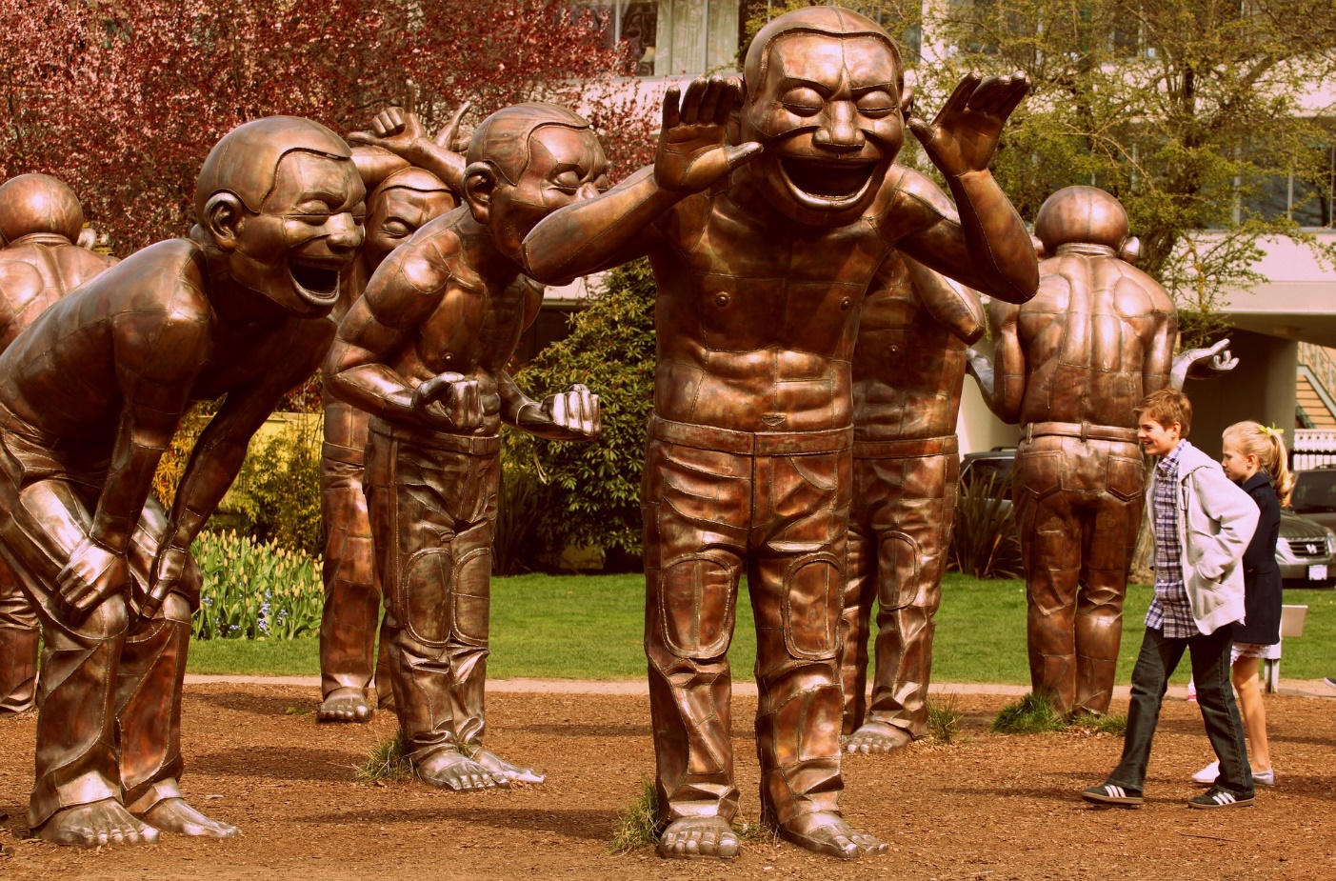





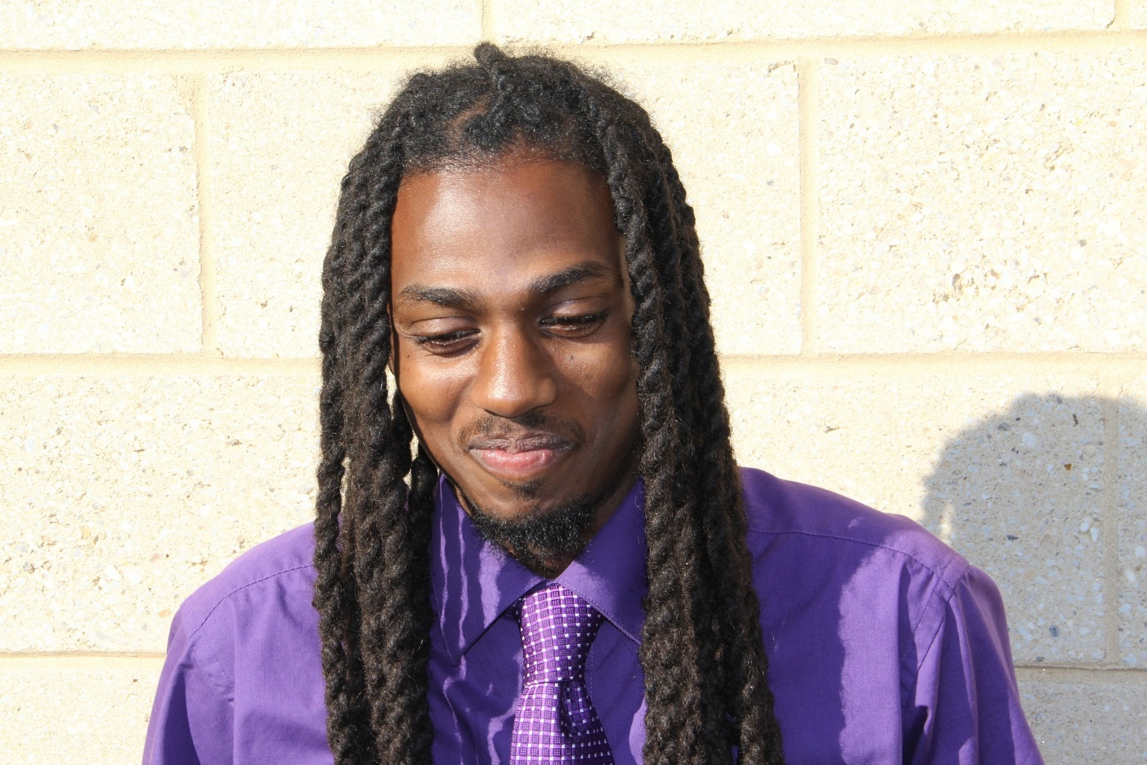

**Which kind(s) of laugh do you think are like Sarah’s laugh?**

**Secondary sources: The role of laughter in life**

**Read and Discuss.**

N.B.: you might like to put these on pieces of card face down on floor/table. One at a time student select a card, read it and comment on it (leave time for other students to respond before the next person selects a card.)

* If you do this before reading the text, then return to the cards after your discussion and see whether they offer insights into Sarah’s laughter.

* If you do this after your discussion, pause after discussing each one and ask “do you think this quote offers a new way of thinking about Sarah’s laughter?

[**Laughter can bring a new perspective.**](http://www.brainyquote.com/quotes/quotes/c/christophe355592.html)   
[Christopher Durang](http://www.brainyquote.com/quotes/authors/c/christopher_durang.html), Playwright, 1949-

http://www.brainyquote.com/quotes/quotes/c/christophe355592.html



[**You can't deny laughter; when it comes, it plops down in your favorite chair and stays as long as it wants.**](http://www.brainyquote.com/quotes/quotes/s/stephenkin106358.html)[Stephen King](http://www.brainyquote.com/quotes/authors/s/stephen_king.html), author, 1947-

http://www.brainyquote.com/quotes/quotes/s/stephenkin106358.html

Image: openclipart.org



**Laughter can help relieve tension in even the**

**heaviest of matters** [Allen Klein](http://www.brainyquote.com/quotes/authors/a/allen_klein.html), author, 1938

http://www.brainyquote.com/quotes/quotes/a/allenklein285037.html  
 Image: openclipart.org

[**It is impossible for you to be angry and laugh at the same time. Anger and laughter are mutually exclusive and you have the power to choose either.**](http://www.brainyquote.com/quotes/quotes/w/waynedyer127372.html)

[Wayne Dyer](http://www.brainyquote.com/quotes/authors/w/wayne_dyer.html), Psychologist, 1940-2015  
http://www.brainyquote.com/quotes/quotes/w/waynedyer127372.html

**There is a thin line that separates laughter and pain, comedy and tragedy, humor and hurt.**

Erma Bombeck, Journalist, 1927-1996  
http://www.brainyquote.com/quotes/quotes/e/ermabombec133166.html?src=t_laughter

**I think laughter may be a form of courage. As humans we sometimes stand tall and look into the sun and laugh, and I think we are never more brave than when we do that.**

Linda Ellerbee, Journalist, 1944-   
<http://www.brainyquote.com/quotes/quotes/l/lindaeller402588.html?src=t_laughter>

**Leading Idea: Telling Lies**

When God asks Abraham why Sarah laughs Sarah denies that she did so. Is this denial? Embarrassment? Fear? A lie or… maybe even the truth (if she ‘laughed within’, managing to suppress her laugh, has she still laughed? (is she embarrassed? Is she in denial? Is it possible she was so amazed she was unaware of laughing? Or maybe, if she had worked to suppress her laughter, she now wanted to assert that she hadn’t really laughed because she had consciously controlled herself from doing so, keeping her laughter within.)

At face value this seems a pretty clear cut case of lying – yet god does not administer any form of divine retribution. Why does Sarah get no punishment? Could it be because it was in some way excusable? If so what would make it so? Sarah lies because she was yirah – in fear, or struck with awe – Can we be so overwhelmed that we lie without intending to? (it just slips out?).

The discussion plan explores lying and the texts that come after explore lies that seem to be good lies. Could Sarah’s lie be of this sort, If so, how would we have to understand the situation she was in?

**Discussion Plan: Telling Lies**

1. Does 'lying' have more than one meaning?
2. Can you say something that is false without it being a lie?
3. Are there different sorts of lies?
4. What is the difference between them? Are they equally wrong/right?
5. Is exaggeration a form of lying?
6. Can you lie without meaning to?
7. Can you tell the truth without meaning to?
8. If your lie turns out to be the truth have you still lied?
9. What are some of the likely consequences of lying?
10. Is lying ever justified?

**Secondary Soures: Lying: Aaron, Lover and pursuer of peace**

*Retell this story to your students or have them read it. You may need to simplify the language, but the ideas behind the story should not be simplified***.**

**Lying: Aaron, Lover and pursuer of peace**

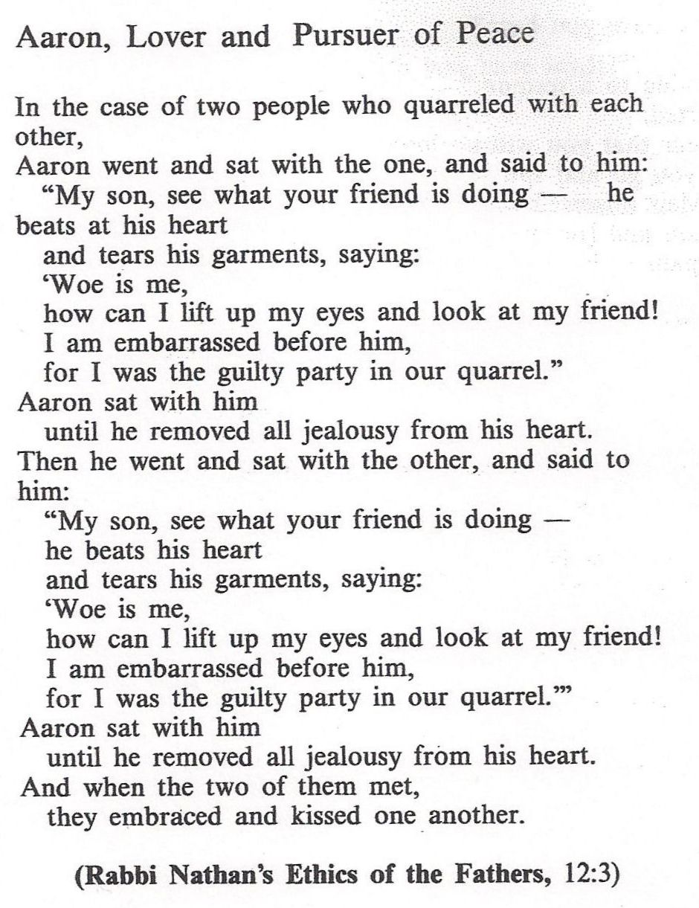



**Some Questions you might like to ask**

* How do you think the friends would react if they found out Aaron had made this up?
* How do you think Aaron would describe what he did?
* Do you think Aaron should have done something different?

You might like to act out the story in light of these questions.

**Leading Idea: Sarah’s Miracle?**

The text tells us that when Sarah gave birth to Yitzak she was 95 years old. Even if Biblical years are calculated differently, the story tells us she was past childbearing years, and of a ripe old age. Is this, then, a Miracle? If so, what kind of miraculous event is this? Use the resources on Miracles in Parshat Shemot to explore this (and yes I know we need some sources from women here – just having trouble finding some so if you do…..

Note, that the sources are for primary and high school – so pick ones appropriate to your age class if you take up this topic.

**Discussion Plan: Miracles**

*Discuss what the term ‘miracle’ means in each of these sentences*

1. “It was a miracle he survived the accident”
2. “At Hannukah we talk about the miracle of the oil”
3. “When my baby brother was born and I saw him for the first time I thought ‘this is a miracle’”
4. “The trapeze artist performed miraculous feats of daring”
5. “My biology teacher talks about the miracle of life on earth”
6. “It was a miracle that I got my homework done on time”
7. “The magician pulled a rabbit out of the hat – it was a miracle!’
8. I used to take butterflies for granted, but now we have studied them, I think each one is a tiny miracle!

**Discussion Plan: What counts as a miracle?**

1. In the storm, a bolt of lightning came down and split the tree in half.
2. I fell off my bike speeding down the hill, but didn’t even get a scratch.
3. I wanted an ice-cream but didn’t have any money me –then I found $1.00 on the ground, so I could buy one.
4. When I saw the fire truck going to a house that was on fire, I prayed that everyone would get out of the fire safely and they did.
5. I wake up every morning feeling fresh and ready to start the day.
6. When the forest fire was out of control, the wind turned and the rain came and put it out.



1. God created the world in seven days.
2. I prayed that something bad would happen to the boy at school who is always teasing me, and then he broke his arm.
3. A standard passenger plane weighs more than 100 adult elephants when it is loaded, and yet it can still get into the air and fly!

**Exercise: What counts as a miracle?**

For the items listed above (1-12) decide which word best describes it.

Miracle Miraculous Awesome Lucky Ordinary Something else?

**Secondary Sources on daily miracles**

**Rabbinic notion of daily miracles**: "Come and consider how many miracles the Holy One blessed be He, performs for people, and they are unaware of it. If a person was to swallow bread without chewing it, it would hurt them terribly, but God created people with mouths which lets them to chew and then swallow." (Exodus Rabba 24:1).

This idea is expressed in the daily prayer (modim anachnu lach) "For Thy miracles which are daily, and for Thy wonders and Thy benefits, which are wrought **at all times, evening, morning and night**."

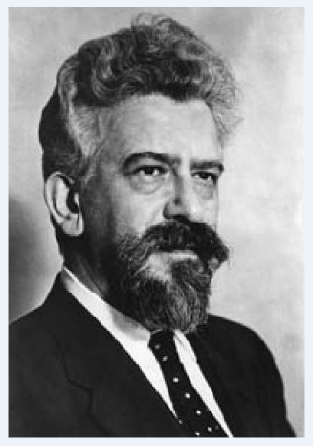

**Avraham Joshua Heschel** talked about the mystery of the universe – how it came to be like it is and the rules that make it work – and how that makes us feel a great sense of wonder” (God in Search of Man,)

Image: Wikimedia Commons.

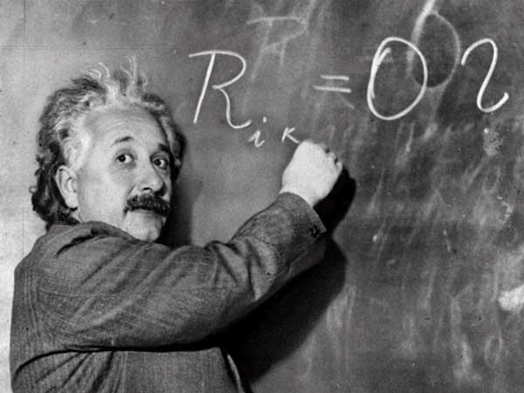

# Albert Einstein

# “There are two ways to live: you can live as if nothing is a miracle; you can live as if everything is a miracle.”

Image: https://i.ytimg.com/vi/paLdIlvLtaw/hqdefault.jpg



**“I think miracles exist in part as gifts and in part as clues that there is something beyond the flat world we see.”**

**Peggy Noonan**   
*Peggy Noonan is a columnist for The Wall Street Journal. She has written eight books on American politics and culture.* Quote is from: What I Saw at the Revolution: A Political Life in the Reagan Era (1990)

*http://www.peggynoonan.com/*

**China’s Miracle Man**:

*Monday, July 9, 2007*. He survived against all the odds; now Peng Shulin has astounded doctors by learning to walk again. When his body was cut in two by a lorry in 1995, it was little short of a medical miracle that he lived. It took a team of more than 20 doctors to save his life.

Doctors at the China Rehabilitation Research Centre in Beijing found out about Mr Peng’s plight late last year and devised a plan to get him up walking again.

They came up with an ingenious way to allow him to walk on his own, creating a sophisticated egg cup-like casing to hold his body with two bionic legs attached to it.

He has been taking his first steps around the centre with the aid of his specially adapted legs and a resized walking frame. Mr Peng, who has to learn how to walk again, is said to be delighted with the device.

In November 2009, the Australian Daily Telegraph reported that Peng had opened his own bargain supermarket, called the Half Man-Half Price Store.

What self-confidence… and optimism…



Secondary Sources on daily miracles – MS-A

<http://metro.co.uk/2007/07/09/miracle-man-walks-again-513316/>

<http://www.snopes.com/photos/people/peng.asp>

For MS-A

**Rabbinic notion of daily miracles**: "Come and consider how many miracles the Holy One blessed be He, performs for man, and he is unaware of it. If a man were to swallow bread without chewing it, it would hurt him terribly, but God created people with mouths which enables them to chew and swallow." (Exodus Rabba 24:1).

This idea is expressed in the daily prayer (modim anachnu lach) "For Thy miracles which are daily, and for Thy wonders and Thy benefits, which are wrought **at all times, evening, morning and night**."



**Avraham Joshua Heschel** introduces the term 'the legacy of wonder' or 'radical amazement' referring to how Biblical figures interpreted miracles and their meaning for humans living in contemporary times. He wrote: "What stirred their souls was neither the hidden nor the apparent, but 'the hidden in the apparent'; not the order but the mystery of the order that prevails in the universe." (God in Search of Man, p. 56)

Image: Wikimedia Commons.

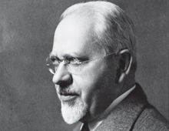

**Mordechai Kaplan** explains the miracles in Jewish literature as reflecting the attempt "of the ancient authors to prove and illustrate God's power and goodness" (Judaism as Civilization, p. 98) Kaplan maintained that these traditions concerning miracles were in conflict with modern thought, and that the belief in miracles that contravene natural law is a "psychological impossibility for most people." (Questions Jews Ask, p. 155-156).

Image: http://americanjewisharchives.org/education/timeline/kaplan.html



# Albert Einstein

# “There are two ways to live: you can live as if nothing is a miracle; you can live as if everything is a miracle.”

Image: https://i.ytimg.com/vi/paLdIlvLtaw/hqdefault.jpg

### Evidence & Belief

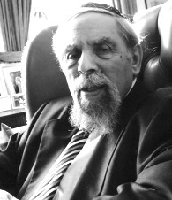The real question for moderns is not *can* miracles happen, but did they and do they happen. As Hume recognized, the question is one of evidence. Many events that were seen in the past as miracles can now be understood as due to the operation of natural laws, even though Hume himself is less than categorical about the absolute necessity of cause *A*always to produce the effect *B*it usually seems to produce.

Undoubtedly, a modern Jewish believer will be far less prone to attribute extraordinary events to a supernatural intervention, but his belief in God's power will not allow him to deny the very possibility of miracles occurring.

A Hasidic saying has it that a Hasid who believes that all the miracles said to have been performed by the Hasidic masters actually happened is a fool, but anyone who believes that they could not have happened is an unbeliever. The same can be said of miracles in general.

*Rabbi Dr. Louis Jacobs (1920-2006) was a Masorti rabbi, the first leader of Masorti Judaism (also known as Conservative Judaism) in the United Kingdom, and a leading writer and thinker on Judaism.*

Image: https://en.wikipedia.org/wiki/Louis_Jacobs#/media/File:Rabbijacobs.jpg

**China’s Miracle Man**:

*Monday, July 9, 2007*. He survived against all the odds; now Peng Shulin has astounded doctors by learning to walk again. When his body was cut in two by a lorry in 1995, it was little short of a medical miracle that he lived. It took a team of more than 20 doctors to save his life.

Doctors at the China Rehabilitation Research Centre in Beijing found out about Mr Peng’s plight late last year and devised a plan to get him up walking again.

They came up with an ingenious way to allow him to walk on his own, creating a sophisticated egg cup-like casing to hold his body with two bionic legs attached to it.

He has been taking his first steps around the centre with the aid of his specially adapted legs and a resized walking frame. Mr Peng, who has to learn how to walk again, is said to be delighted with the device.

What self-confidence… and optimism…





**“I think miracles exist in part as gifts and in part as clues that there is something beyond the flat world we see.”**

**Peggy Noonan**



*Peggy Noonan is a columnist for The Wall Street Journal. She has written eight books on American politics and culture.* Quote is from: What I Saw at the Revolution: A

Political Life in the Reagan Era (1990)

In November 2009, the Australian Daily Telegraph reported that Peng had opened his own bargain supermarket, called the Half Man-Half Price Store.

<http://metro.co.uk/2007/07/09/miracle-man-walks-again-513316/>

<http://www.snopes.com/photos/people/peng.as>

[p](http://www.snopes.com/photos/people/peng.asp)

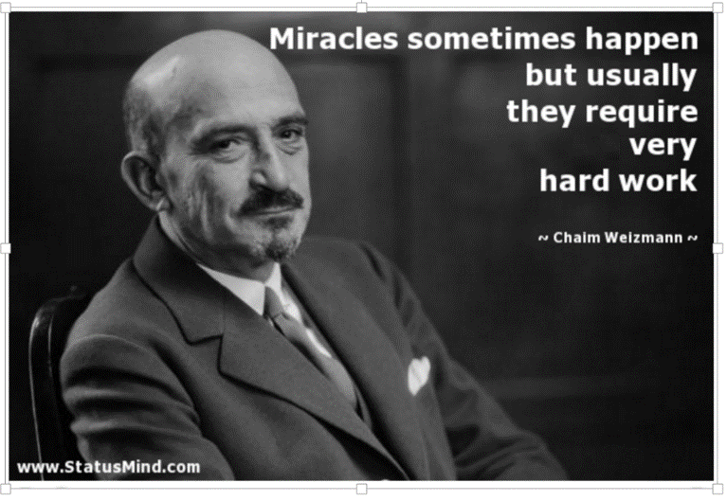



**Chaim Weizmann** was the [first](https://en.wikipedia.org/wiki/List_of_Presidents_of_Israel) [President of Israel](https://en.wikipedia.org/wiki/President_of_Israel). He was [elected](https://en.wikipedia.org/wiki/Israeli_presidential_election,_1949) on 16 February 1949, and served until his death in 1952. For more information, see:

http://www.jewishvirtuallibrary.org/jsource/biography/weizmann.html